UNITED STATES
SECURITIES AND EXCHANGE COMMISSION
WASHINGTON, D.C. 20549

FORM 8-K

CURRENT REPORT
Pursuant to Section 13 or 15(d) of the Securities Exchange Act of 1934
Date of Report (Date of earliest event reported): August 06, 2026

MBX Biosciences, Inc.
(Exact name of Registrant as Specified in Its Charter)

Delaware |  |  | 001-42272 | 84-1882872
(State or Other Jurisdiction  of Incorporation) |  |  | (Commission File Number) | (IRS Employer  Identification No.)
11711 N. Meridian Street
Suite 300
Carmel, Indiana |  |  |  | 46032
(Address of Principal Executive Offices) |  |  |  | (Zip Code)

Registrant’s Telephone Number, Including Area Code: (317) 659-0200

Not Applicable
(Former Name or Former Address, if Changed Since Last Report)

Check the appropriate box below if the Form 8-K filing is intended to simultaneously satisfy the filing obligation of the registrant under any of the following provisions:
☐Written communications pursuant to Rule 425 under the Securities Act (17 CFR 230.425)
☐Soliciting material pursuant to Rule 14a-12 under the Exchange Act (17 CFR 240.14a-12)
☐Pre-commencement communications pursuant to Rule 14d-2(b) under the Exchange Act (17 CFR 240.14d-2(b))
☐Pre-commencement communications pursuant to Rule 13e-4(c) under the Exchange Act (17 CFR 240.13e-4(c))
Securities registered pursuant to Section 12(b) of the Act:
Title of each class |  | Trading  Symbol(s) |  | Name of each exchange on which registered
Common Stock, $0.0001 par value per share |  | MBX |  | Nasdaq Global Select Market
Indicate by check mark whether the registrant is an emerging growth company as defined in Rule 405 of the Securities Act of 1933 (§ 230.405 of this chapter) or Rule 12b-2 of the Securities Exchange Act of 1934 (§ 240.12b-2 of this chapter).
Emerging growth company ☒
If an emerging growth company, indicate by check mark if the registrant has elected not to use the extended transition period for complying with any new or revised financial accounting standards provided pursuant to Section 13(a) of the Exchange Act. ☐

Item 2.02 Results of Operations and Financial Condition.
On August 6, 2026, MBX Biosciences, Inc. (the "Company") announced its financial results for the quarter ended June 30, 2026. A copy of the press release is being furnished as Exhibit 99.1 to this Current Report on Form 8-K.
The information included under Item 2.02 of this Current Report on Form 8-K (including Exhibit 99.1 attached hereto), is intended to be furnished and shall not be deemed "filed" for purposes of Section 18 of the Securities Exchange Act of 1934, as amended (the "Exchange Act"), or otherwise subject to the liabilities of that section, and shall not be deemed incorporated by reference in any filing under the Securities Act of 1933, as amended, or the Exchange Act, except as expressly set forth by specific reference in such filing.

Item 7.01 Regulation FD Disclosure.
On August 6, 2026, the Company updated its corporate presentation. The corporate presentation is available in the "Investors" section of the Company's website at www.mbxbio.com and is furnished as Exhibit 99.2 to this Current Report on Form 8-K.

The information included under Item 7.01 of this Current Report on Form 8-K, including Exhibit 99.2 attached hereto, is intended to be furnished and shall not be deemed "filed" for purposes of Section 18 of the Exchange Act, or otherwise subject to the liabilities of that section, and shall not be deemed incorporated by reference in any filing under the Securities Act of 1933, as amended, or the Exchange Act, except as expressly set forth by specific reference in such filing.

Item 8.01 Other Events.
On August 6, 2026, the Company provided an update on its MBX 4291 phase 1 clinical trial. The Company remains on track to report data from the first cohort of the 12-week multiple ascending dose (Part C) in the fourth quarter of 2026. The first cohort in Part C is evaluating a 30 mg (once-weekly times four) plus 120 mg (once-monthly) plus 180 mg (once-monthly) titration regimen in adult participants with obesity (body mass index ≥30).

Forward-Looking Statements
This Current Report on Form 8-K contains “forward-looking statements” within the meaning of Section 27A of the Securities Act of 1933 and Section 21E of the Securities Exchange Act of 1934, each as amended. The words “anticipate,” “believe,” “continue,” “could,” “estimate,” “expect,” “intend,” “may,” “plan,” “potential,” “predict,” “project,” “should,” “target,” “would” and similar expressions are intended to identify forward-looking statements, although not all forward-looking statements contain these identifying words. These forward-looking statements include, but are not limited to, express or implied statements regarding: MBX Biosciences’ expectations regarding the further advancement of its pipeline of programs in endocrine and metabolic disorders, including timing of results of the 12-week MAD portion of the Phase 1 trial for MBX 4291 in Q4 2026.
Forward-looking statements are based on management’s current expectations and are subject to risks and uncertainties that could negatively affect MBX Biosciences’ business, operating results, financial condition and stock value. Factors that could cause actual results to differ materially from those currently anticipated include: risks relating to the Company’s research and development activities; MBX Biosciences’ ability to execute on its strategy including obtaining the requisite regulatory approvals on the expected timeline, if at all; uncertainties relating to preclinical and clinical development activities, including the risk for differences between interim data and final data from the Company’s ongoing clinical trials; the Company’s dependence on third parties to conduct clinical trials, manufacture its product candidates and develop and commercialize its product candidates, if approved; MBX Biosciences’ ability to attract, integrate and retain key personnel; risks related to the Company’s financial condition and need for substantial additional funds in order to complete development activities and commercialize a product candidate, if approved; risks related to regulatory developments and approval processes of the U.S. Food and Drug Administration and comparable foreign regulatory authorities; risks related to establishing and maintaining MBX Biosciences’ intellectual property protections; and risks related to the competitive landscape for MBX Biosciences’ product candidates; as well as other risks described in “Risk Factors,” in MBX Biosciences’ Annual Report on Form 10-K for the year ended December 31, 2025, Quarterly Report on Form 10-Q for the three months ended March 31, 2026,Quarterly Report on Form 10-Q for the three and six months ended June 30, 2026, as well as subsequent filings filed with the Securities and Exchange Commission (SEC). MBX Biosciences expressly disclaims any obligation or undertaking to release publicly any updates or revisions to any forward-looking statements contained herein to reflect any change in its expectations or any changes in events, conditions or circumstances on which any such statement is based, except as required by law, and claims the protection of the safe harbor for forward-looking statements contained in the Private Securities Litigation Reform Act of 1995.

Item 9.01 Financial Statements and Exhibits.
(d) Exhibits.

Exhibit No. | Description
99.1 | Press Release Issued by MBX Biosciences, Inc. on May 7, 2026
99.2 | Corporate presentation of MBX Biosciences, Inc.
104 | Cover Page Interactive Data File (embedded within the Inline XBRL document)

SIGNATURES
Pursuant to the requirements of the Securities Exchange Act of 1934, the registrant has duly caused this report to be signed on its behalf by the undersigned hereunto duly authorized.
 |  |  | MBX Biosciences, Inc.
Date: | August 6, 2026 | By: | /s/ Steven L. Hoerter
 |  |  | President and Chief Executive Officer (Principal Executive Officer)

EXHIBIT 99.1


MBX Biosciences Reports Second Quarter 2026 Financial Results and Corporate Highlights

One-year data demonstrated sustained benefit of once-weekly canvuparatide as a potential PTH replacement therapy in chronic hypoparathyroidism; Phase 3 pivotal trial now recruiting

Initial Phase 1 data for MBX 4291, a GLP-1/GIP co-agonist prodrug for obesity, support potential for once-monthly dosing; data from 12-week MAD (Part C) on track for Q4 2026

Nomination of development candidate MBX 6180, a GLP-1/GIP/GCG triple agonist prodrug designed for once-monthly dosing, further expands obesity portfolio

$418.6 million in cash and investments expected to support operations into 2029

CARMEL, Ind., and BURLINGTON, Mass., Aug. 6, 2026 (GLOBE NEWSWIRE) -- MBX Biosciences, Inc. (Nasdaq: MBX), a clinical-stage biopharmaceutical company focused on the discovery, development and commercialization of novel precision peptide therapies for the treatment of endocrine and metabolic disorders, today reported financial results for the second quarter ended June 30, 2026, and highlighted recent corporate progress.

“The second quarter was highlighted by important milestones across our pipeline, including a first look at clinical data for MBX 4291 supporting its potential for true once-monthly dosing in obesity,” said Steve Hoerter, Chairman and Chief Executive Officer of MBX Biosciences. "In addition, we were proud to present the full Phase 2 and one-year OLE data for once-weekly canvuparatide, which demonstrated sustained benefit and the potential to become a best-in-class treatment for patients with chronic hypoparathyroidism. Now we look forward to dosing the first patients in our Phase 3 trial of canvuparatide this quarter and to presenting 12-week multiple ascending dose (MAD) data for MBX 4291 in the fourth quarter. With a strong balance sheet and an experienced team, we continue to leverage our proprietary PEP platform to develop differentiated, long-acting peptide therapies with the potential to meaningfully improve patients’ lives."

Second Quarter 2026 and Corporate Highlights

Once-Weekly Canvuparatide for Hypoparathyroidism (HP)

•
Full Phase 2 results and one-year OLE data presented at ENDO 2026: Results demonstrated sustained benefit of once-weekly canvuparatide as a potential PTH replacement therapy through one year, with findings consistent with restoration of systemic PTH activity through normalization of serum calcium, reduction of urine calcium excretion and restoration of bone metabolism, as well as a safety profile and pharmacokinetics supporting once-weekly dosing.
ACTIVE/205001800.2

•
Phase 3 trial of once-weekly canvuparatide now recruiting: MBX remains on track to initiate a Phase 3 pivotal trial of once-weekly canvuparatide in chronic hypoparathyroidism in Q3 2026. Clinical trial sites have been activated, and participants are currently being recruited and screened. The oPTimize Phase 3 pivotal, global, multicenter, randomized, double-blind placebo-controlled study will evaluate the safety, pharmacokinetics and efficacy of once-weekly canvuparatide in patients with HP.

MBX 4291 and Expanding Obesity Pipeline

•
Initial Phase 1 data for MBX 4291 supports potential for once-monthly dosing: Preliminary blinded data from the ongoing Phase 1 trial of MBX 4291, a dual GLP-1/GIP receptor agonist peptide prodrug, in adults with obesity demonstrated mean weight loss of 7% (range, 0–16%) at eight weeks (n=8, including 2 placebo) in the first multiple ascending dose (MAD) Part B cohort, with MBX 4291 generally well tolerated through eight weeks. The Company remains on track to report data from the first cohort of the 12-week MAD (Part C) in Q4 2026. Cohort C1 is evaluating a 30 mg (once-weekly x 4) + 120 mg (once-monthly) + 180 mg (once-monthly) titration regimen in adult participants with obesity (BMI ≥ 30).

•
Nomination of MBX 6180 as GLP-1/GIP/GCG triple agonist prodrug development candidate: The Company today announced nomination of MBX 6180 as its lead GLP-1/GIP/glucagon (GCG) triple agonist prodrug candidate, further expanding its obesity pipeline to potentially address the full spectrum of patient needs. MBX 6180 combines GLP-1, GIP and GCG receptor agonist activity in a single construct. The differentiated design of MBX 6180 is intended to provide a pharmacokinetic profile supporting once-monthly dosing. The Company expects to present preclinical data from MBX 6180 at a scientific meeting in the fourth quarter of 2026. IND-enabling studies are now underway.

•
Nomination of MBX 5765 as amycretin prodrug development candidate: In May 2026, MBX nominated MBX 5765 as its lead amycretin prodrug development candidate. Enabled by the Company's proprietary PEP platform, MBX 5765 combines GLP-1, GIP, GCG, and dual amylin and calcitonin receptor agonist (DACRA) activity in a single peptide construct. The differentiated mechanism of MBX 5765 is designed for once-monthly dosing, superior efficacy and improved tolerability. IND-enabling studies are ongoing.

Corporate

•
Executive Appointments to Support Next Phase of Growth: Steve Hoerter, current Executive Chairman of the MBX Board, was appointed Chairman and Chief Executive Officer, succeeding Kent Hawryluk. Mr. Hoerter joined the MBX Board of Directors in April 2025 and was appointed Executive Chairman in November 2025. In addition, John Smither, previously the Interim Chief Financial Officer, was appointed as Chief Financial Officer.

Anticipated Milestones

Canvuparatide

•
Q3 2026: Initiation of pivotal Phase 3 oPTimize trial

MBX 4291

•
Q4 2026: Results from the first cohort of the 12-week MAD (Part C) portion of the ongoing Phase 1 trial

Second Quarter 2026 Financial Results

•
Cash and Cash Equivalents and Marketable Securities: As of June 30, 2026, MBX had cash, cash equivalents and marketable securities of $418.6 million. Based on its current operating plan, the Company expects the combined cash, cash equivalents and marketable securities balance to fund operations into 2029.

•
R&D Expenses: Research and development expenses for the three months ended June 30, 2026, were $31.0 million, compared to $17.7 million for the same period in 2025. The increase of $13.3 million was driven by an increase in start-up costs related to the canvuparatide Phase 3 clinical trial, ongoing conduct of the canvuparatide Phase 2 open-label extension clinical trial, ongoing conduct of the MBX 4291 Phase 1 clinical trial and timing of preclinical activities related to MBX 5765.

•
G&A Expenses: General and administrative expenses for the three months ended June 30, 2026, were $9.9 million, compared to $4.1 million for the same period in 2025. The increase of $5.9 million was driven by higher personnel-related costs (including stock-based compensation) resulting from continued expansion of both our executive leadership team and general infrastructure to support growth in our operations

•
Net Loss: Net loss for the three months ended June 30, 2026, was $37.1 million compared to a net loss of $19.4 million for the same period in 2025.

About MBX Biosciences

MBX Biosciences is a biopharmaceutical company focused on the discovery, development and commercialization of novel precision peptide therapies based on its proprietary PEP platform, for the treatment of endocrine and metabolic disorders. The Company is advancing a pipeline of novel candidates for endocrine and metabolic disorders with clinically validated targets, established endpoints for regulatory approval, significant unmet medical needs and large potential market opportunities. The Company’s pipeline includes canvuparatide (MBX 2109) for the treatment of chronic hypoparathyroidism in Phase 3 development; and an obesity portfolio that includes MBX 4291 in Phase 1 development and MBX 5765 and MBX 6180 in preclinical development, as well as additional discovery candidates. The Company is based in Carmel, Indiana and Burlington, Massachusetts. To learn more, please visit the company website at www.mbxbio.com and follow it on LinkedIn.

About MBX’s Proprietary Precision Endocrine Peptide (PEP) Platform

MBX was founded by global leaders with a transformative approach to peptide drug design and development. Leveraging this expertise, the Company designed its proprietary Precision Endocrine Peptide (PEP) platform to overcome the key limitations of unmodified and modified peptide therapies and to improve clinical outcomes and simplify disease management

for patients. PEPs are selectively engineered to have optimized pharmaceutical properties, including extended time-action profiles and consistent drug concentrations with low peak-to-trough concentration ratios, consistent exposure to target tissues, and less frequent dosing.

Forward-Looking Statements

This press release contains “forward-looking statements” within the meaning of Section 27A of the Securities Act of 1933 and Section 21E of the Securities Exchange Act of 1934, each as amended. The words “anticipate,” “believe,” “continue,” “could,” “estimate,” “expect,” “intend,” “may,” “plan,” “potential,” “predict,” “project,” “should,” “target,” “would” and similar expressions are intended to identify forward-looking statements, although not all forward-looking statements contain these identifying words. These forward-looking statements include, but are not limited to, express or implied statements regarding: MBX Biosciences’ expectations regarding the further advancement of its pipeline of programs in endocrine and metabolic disorders, including timing of initiation of a Phase 3 trial for canvuparatide in Q3 2026; the potential for canvuparatide to be a once-weekly PTH replacement therapy; the expected timing of the Phase 1 readout for MBX 4291; the timing of additional obesity candidate nominations; the potential for MBX Biosciences to develop therapies for obesity dosed once monthly; and expectations regarding MBX Biosciences’ uses of capital, expenses and financial results, including the anticipated cash runway timing.

Forward-looking statements are based on management’s current expectations and are subject to risks and uncertainties that could negatively affect MBX Biosciences’ business, operating results, financial condition and stock value. Factors that could cause actual results to differ materially from those currently anticipated include: risks relating to the Company’s research and development activities; MBX Biosciences’ ability to execute on its strategy including obtaining the requisite regulatory approvals on the expected timeline, if at all; uncertainties relating to preclinical and clinical development activities; the Company’s dependence on third parties to conduct clinical trials, manufacture its product candidates and develop and commercialize its product candidates, if approved; MBX Biosciences’ ability to attract, integrate and retain key personnel; risks related to the Company’s financial condition and need for substantial additional funds in order to complete development activities and commercialize a product candidate, if approved; risks related to regulatory developments and approval processes of the U.S. Food and Drug Administration and comparable foreign regulatory authorities; risks related to establishing and maintaining MBX Biosciences’ intellectual property protections; risks related to the competitive landscape for MBX Biosciences’ product candidates; and final audit adjustments and other developments that may arise that would cause MBX Biosciences’ expectations with respect to the estimate of cash, cash equivalents and marketable securities as of December 31, 2025 to differ, perhaps materially, from the financial results that will be reflected in MBX Biosciences’ audited consolidated financial statements for the fiscal year ended December 31, 2025; as well as other risks described in “Risk Factors,” in MBX Biosciences’ Quarterly Report on Form 10-Q for the three months ended June 30, 2026, Annual Report on Form 10-K for the year ended December 31, 2025, as well as subsequent filings filed with the Securities and Exchange Commission (SEC). MBX Biosciences expressly disclaims any obligation or undertaking to release publicly any updates or revisions to any forward-looking statements contained herein to reflect any change in its expectations or any changes in events, conditions or circumstances on which any such statement is based, except as required by law, and claims the protection of the safe harbor for forward-looking statements contained in the Private Securities Litigation Reform Act of 1995.

MBX Biosciences uses and intends to continue to use its Investor Relations website as a means of disclosing material nonpublic information and for complying with its disclosure obligations under Regulation FD. Accordingly, investors should monitor the Company's Investor Relations website, in addition to following the Company's press releases, SEC filings, public conference calls, presentations, and webcasts.

Media Contact:
George Shea
We. Communications
gshea@wecommunications.com

Investor Contact:
Jim DeNike
MBX Biosciences
jdenike@mbxbio.com

MBX BIOSCIENCES, INC.

SELECTED FINANCIAL INFORMATION

 | (Unaudited)
Statements of Operations Data: | Three months ended June 30, |  |  |  |  |  |  |  | Six months ended June 30,
(in thousands, except per share and per share data) | 2026 |  |  |  | 2025 |  |  |  | 2026 |  |  |  | 2025
Operating expenses
Research and development | $ | 30,985 |  |  | $ | 17,724 |  |  | $ | 49,459 |  |  | $ | 40,130
General and administrative |  | 9,946 |  |  |  | 4,081 |  |  |  | 18,737 |  |  |  | 8,204
Total operating expenses |  | 40,931 |  |  |  | 21,805 |  |  |  | 68,196 |  |  |  | 48,334
Loss from operations |  | (40,931 | ) |  |  | (21,805 | ) |  |  | (68,196 | ) |  |  | (48,334 | )
Interest and other income, net |  | 3,836 |  |  |  | 2,394 |  |  |  | 7,584 |  |  |  | 5,043
Net loss | $ | (37,095 | ) |  | $ | (19,411 | ) |  | $ | (60,612 | ) |  | $ | (43,291 | )
Net loss per common share, basic and diluted | $ | (0.78 | ) |  | $ | (0.58 | ) |  | $ | (1.29 | ) |  | $ | (1.30 | )
Weighted average number of common shares  outstanding used in computation of net loss  per common share, basic and diluted |  | 47,696,363 |  |  |  | 33,446,385 |  |  |  | 47,139,378 |  |  |  | 33,429,479

 |  | (Unaudited)
Balance Sheets Selected Financial Data: |  | June 30, |  |  |  | December 31,
(in thousands) |  | 2026 |  |  |  | 2025
Cash, cash equivalents and marketable securities |  | $ | 418,581 |  |  | $ | 373,705
Working capital(1) |  |  | 404,202 |  |  |  | 366,044
Total assets |  |  | 435,909 |  |  |  | 385,144
Total liabilities |  |  | 26,370 |  |  |  | 15,921
Accumulated deficit |  |  | (285,088 | ) |  |  | (224,476 | )
Total stockholders’ equity |  |  | 409,539 |  |  |  | 369,223

(1) Working capital is defined as total current assets less total current liabilities. See our financial statements and the related notes thereto included in our Quarterly Report on Form 10-Q for the Quarter Ending June 30, 2026 and Year Ending December 31, 2025 for further details regarding our current assets and current liabilities


Pioneering Precision Peptides for Endocrine and Metabolic Diseases August 2026 Corporate Presentation

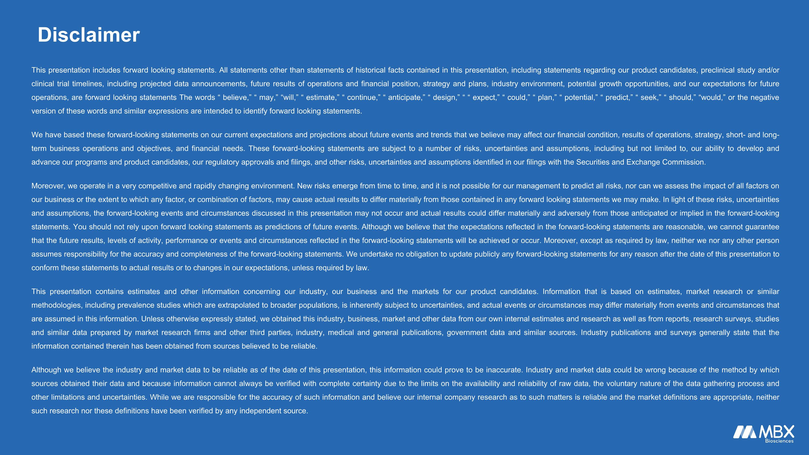
Disclaimer This presentation includes forward looking statements. All statements other than statements of historical facts contained in this presentation, including statements regarding our product candidates, preclinical study and/or clinical trial timelines, including projected data announcements, future results of operations and financial position, strategy and plans, industry environment, potential growth opportunities, and our expectations for future operations, are forward looking statements The words “ believe,” “ may,” “will,” “ estimate,” “ continue,” “ anticipate,” “ design,” “ “ expect,” “ could,” “ plan,” “ potential,” “ predict,” “ seek,” “ should,” “would,” or the negative version of these words and similar expressions are intended to identify forward looking statements. We have based these forward-looking statements on our current expectations and projections about future events and trends that we believe may affect our financial condition, results of operations, strategy, short- and long-term business operations and objectives, and financial needs. These forward-looking statements are subject to a number of risks, uncertainties and assumptions, including but not limited to, our ability to develop and advance our programs and product candidates, our regulatory approvals and filings, and other risks, uncertainties and assumptions identified in our filings with the Securities and Exchange Commission. Moreover, we operate in a very competitive and rapidly changing environment. New risks emerge from time to time, and it is not possible for our management to predict all risks, nor can we assess the impact of all factors on our business or the extent to which any factor, or combination of factors, may cause actual results to differ materially from those contained in any forward looking statements we may make. In light of these risks, uncertainties and assumptions, the forward-looking events and circumstances discussed in this presentation may not occur and actual results could differ materially and adversely from those anticipated or implied in the forward-looking statements. You should not rely upon forward looking statements as predictions of future events. Although we believe that the expectations reflected in the forward-looking statements are reasonable, we cannot guarantee that the future results, levels of activity, performance or events and circumstances reflected in the forward-looking statements will be achieved or occur. Moreover, except as required by law, neither we nor any other person assumes responsibility for the accuracy and completeness of the forward-looking statements. We undertake no obligation to update publicly any forward-looking statements for any reason after the date of this presentation to conform these statements to actual results or to changes in our expectations, unless required by law. This presentation contains estimates and other information concerning our industry, our business and the markets for our product candidates. Information that is based on estimates, market research or similar methodologies, including prevalence studies which are extrapolated to broader populations, is inherently subject to uncertainties, and actual events or circumstances may differ materially from events and circumstances that are assumed in this information. Unless otherwise expressly stated, we obtained this industry, business, market and other data from our own internal estimates and research as well as from reports, research surveys, studies and similar data prepared by market research firms and other third parties, industry, medical and general publications, government data and similar sources. Industry publications and surveys generally state that the information contained therein has been obtained from sources believed to be reliable. Although we believe the industry and market data to be reliable as of the date of this presentation, this information could prove to be inaccurate. Industry and market data could be wrong because of the method by which sources obtained their data and because information cannot always be verified with complete certainty due to the limits on the availability and reliability of raw data, the voluntary nature of the data gathering process and other limitations and uncertainties. While we are responsible for the accuracy of such information and believe our internal company research as to such matters is reliable and the market definitions are appropriate, neither such research nor these definitions have been verified by any independent source.

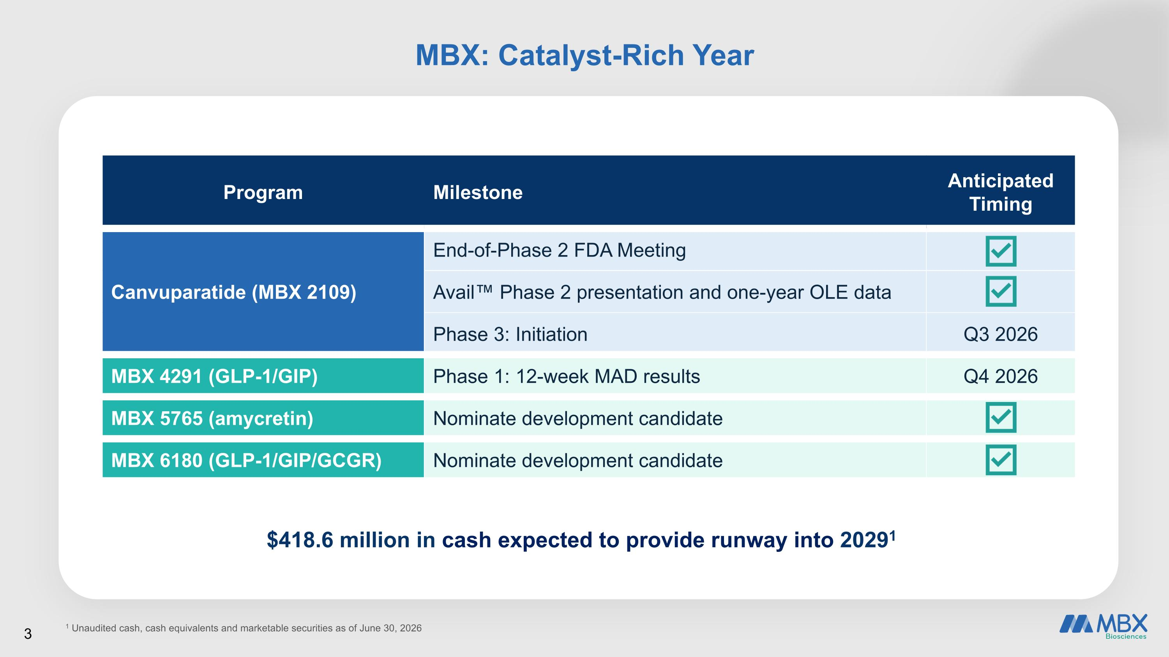
$418.6 million in cash expected to provide runway into 20291 Program Milestone Anticipated Timing Canvuparatide (MBX 2109) End-of-Phase 2 FDA Meeting Avail Phase 2 presentation and one-year OLE data Phase 3: Initiation Q3 2026 MBX 4291 (GLP-1/GIP) Phase 1: 12-week MAD results Q4 2026 MBX 5765 (amycretin) Nominate development candidate MBX 6180 (GLP-1/GIP/GCGR) Nominate development candidate 1 Unaudited cash, cash equivalents and marketable securities as of June 30, 2026 MBX: Catalyst-Rich Year 3

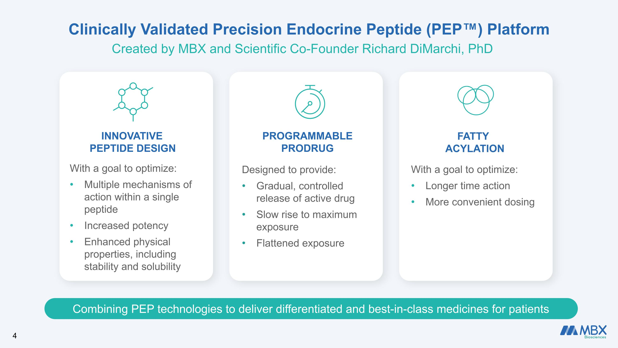
Clinically Validated Precision Endocrine Peptide (PEP) Platform Created by MBX and Scientific Co-Founder Richard DiMarchi, PhD INNOVATIVE ?PEPTIDE DESIGN With a goal to optimize: Multiple mechanisms of action within a single peptide Increased potency Enhanced physical properties, including stability and solubility PROGRAMMABLE PRODRUG Designed to provide: Gradual, controlled release of active drug Slow rise to maximum exposure Flattened exposure Fatty Acylation With a goal to optimize: Longer time action More convenient dosing Combining PEP technologies to deliver differentiated and best-in-class medicines for patients 4


Canvuparatide Investigational Once-Weekly PTH Replacement Therapy for Hypoparathyroidism

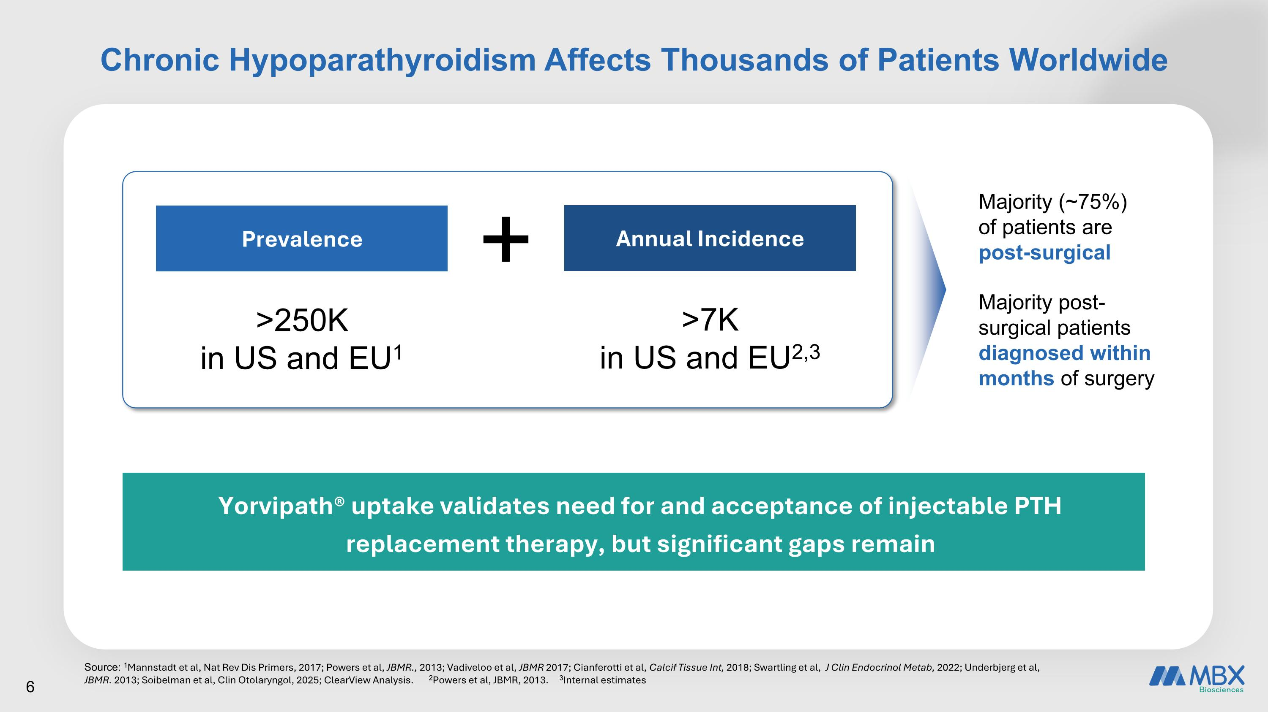
Chronic Hypoparathyroidism Affects Thousands of Patients Worldwide Source: 1Mannstadt et al, Nat Rev Dis Primers, 2017; Powers et al, JBMR., 2013; Vadiveloo et al, JBMR 2017; Cianferotti et al, Calcif Tissue Int, 2018; Swartling et al, J Clin Endocrinol Metab, 2022; Underbjerg et al, JBMR. 2013; Soibelman et al, Clin Otolaryngol, 2025; ClearView Analysis. 2Powers et al, JBMR, 2013. 3Internal estimates + Prevalence >250K in US and EU1 Annual Incidence >7K in US and EU2,3 Yorvipath® uptake validates need for and acceptance of injectable PTH replacement therapy, but significant gaps remain Majority (~75%) of patients are post-surgical Majority post-surgical patients diagnosed within months of surgery 6

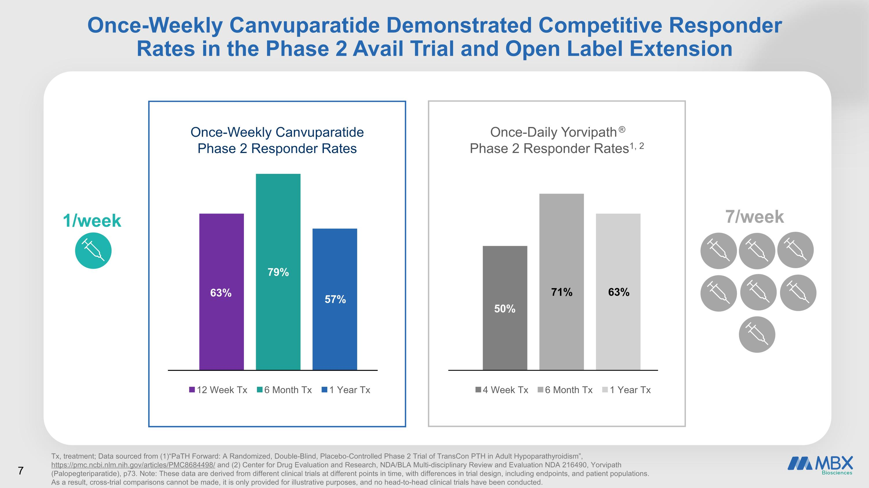
Once-Weekly Canvuparatide Demonstrated Competitive Responder Rates in the Phase 2 Avail Trial and Open Label Extension Tx, treatment; Data sourced from (1)“PaTH Forward: A Randomized, Double-Blind, Placebo-Controlled Phase 2 Trial of TransCon PTH in Adult Hypoparathyroidism”, https://pmc.ncbi.nlm.nih.gov/articles/PMC8684498/ and (2) Center for Drug Evaluation and Research, NDA/BLA Multi-disciplinary Review and Evaluation NDA 216490, Yorvipath (Palopegteriparatide), p73. Note: These data are derived from different clinical trials at different points in time, with differences in trial design, including endpoints, and patient populations. As a result, cross-trial comparisons cannot be made, it is only provided for illustrative purposes, and no head-to-head clinical trials have been conducted. 63% 57% Once-Weekly Canvuparatide ?Phase 2 Responder Rates 79% 63% 50% Once-Daily Yorvipath® ?Phase 2 Responder Rates1, 2 71% 7/week​ 1/week​ 7

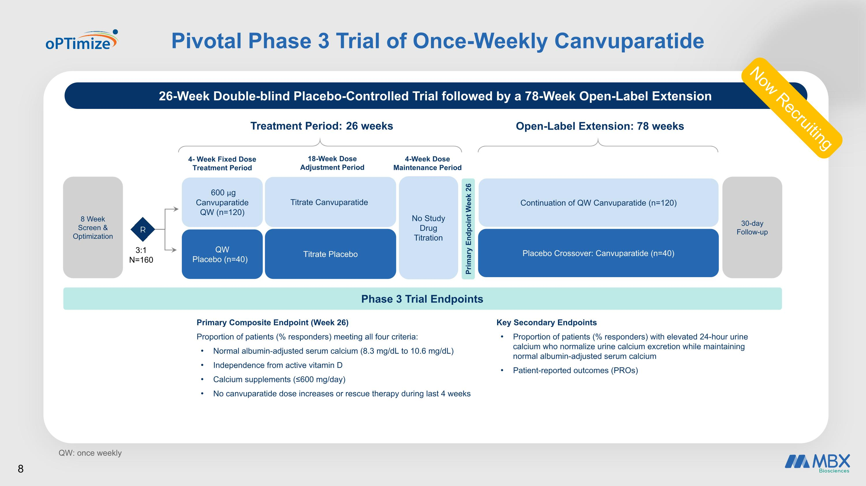
Pivotal Phase 3 Trial of Once-Weekly Canvuparatide QW: once weekly Phase 3 Trial Endpoints Treatment Period: 26 weeks 4- Week Fixed Dose Treatment Period 18-Week Dose ?Adjustment Period 3:1 N=160 600 μg Canvuparatide QW (n=120) QW Placebo (n=40) Titrate Canvuparatide Titrate Placebo Open-Label Extension: 78 weeks Placebo Crossover: Canvuparatide (n=40) Continuation of QW Canvuparatide (n=120) Primary Endpoint Week 26 Primary Composite Endpoint (Week 26) Proportion of patients (% responders) meeting all four criteria: Normal albumin-adjusted serum calcium (8.3 mg/dL to 10.6 mg/dL) Independence from active vitamin D Calcium supplements (≤600 mg/day) No canvuparatide dose increases or rescue therapy during last 4 weeks Key Secondary Endpoints Proportion of patients (% responders) with elevated 24-hour urine calcium who normalize urine calcium excretion while maintaining normal albumin-adjusted serum calcium Patient-reported outcomes (PROs) 26-Week Double-blind Placebo-Controlled Trial followed by a 78-Week Open-Label Extension 4-Week Dose ?Maintenance Period No Study Drug Titration 8 Week Screen & Optimization 30-day Follow-up R 8 Now Recruiting

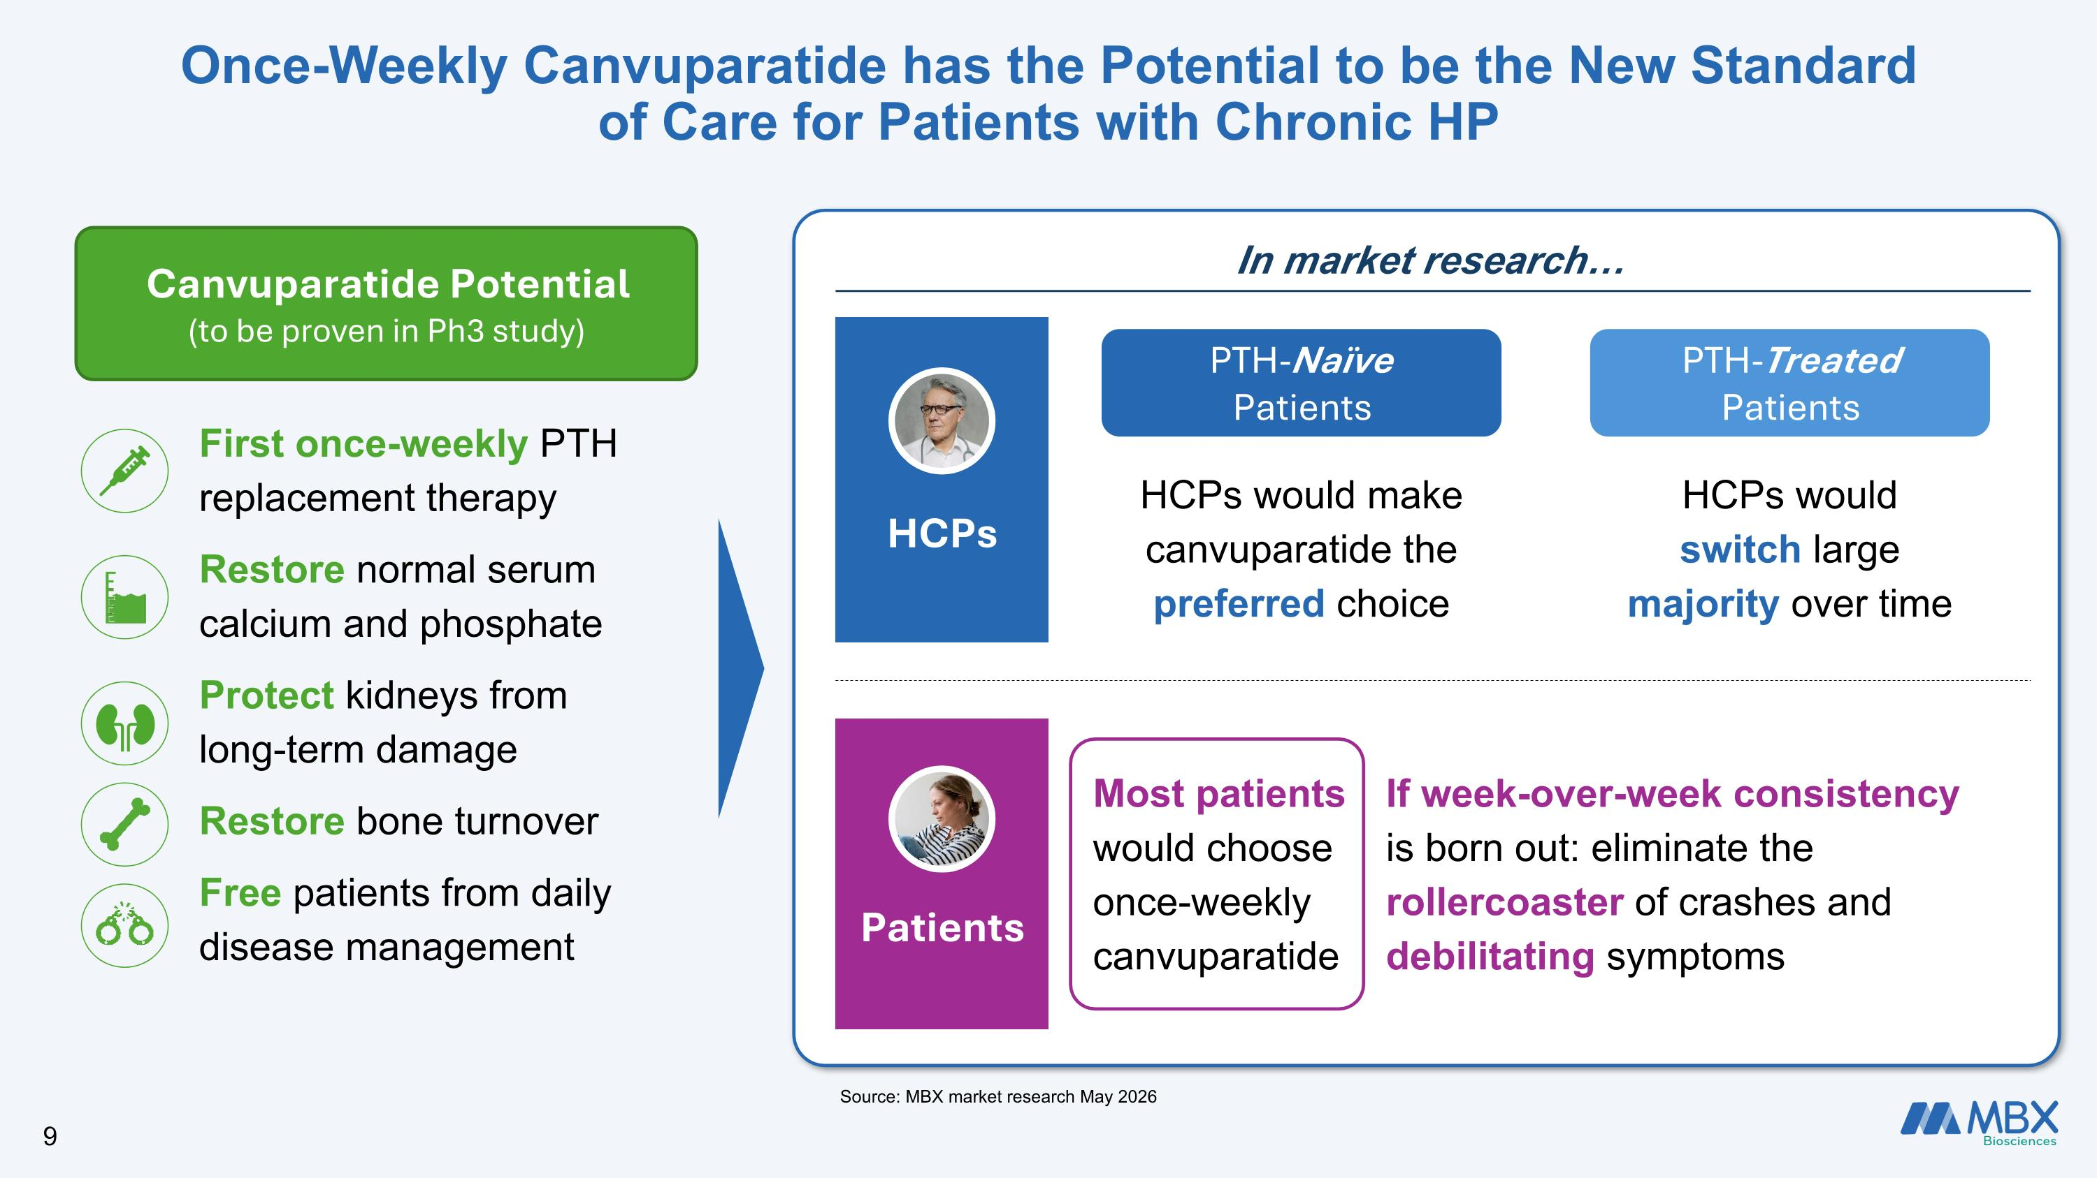
Once-Weekly Canvuparatide has the Potential to be the New Standard of Care for Patients with Chronic HP Source: MBX market research May 2026 First once-weekly PTH replacement therapy Restore normal serum calcium and phosphate Protect kidneys from long-term damage Restore bone turnover Free patients from daily disease management Canvuparatide Potential (to be proven in Ph3 study) Patients HCPs would make canvuparatide the preferred choice PTH-Naïve Patients HCPs would switch large majority over time PTH-Treated Patients If week-over-week consistency is born out: eliminate the rollercoaster of crashes and debilitating symptoms Most patients would choose once-weekly canvuparatide HCPs In market research 9


Obesity Portfolio

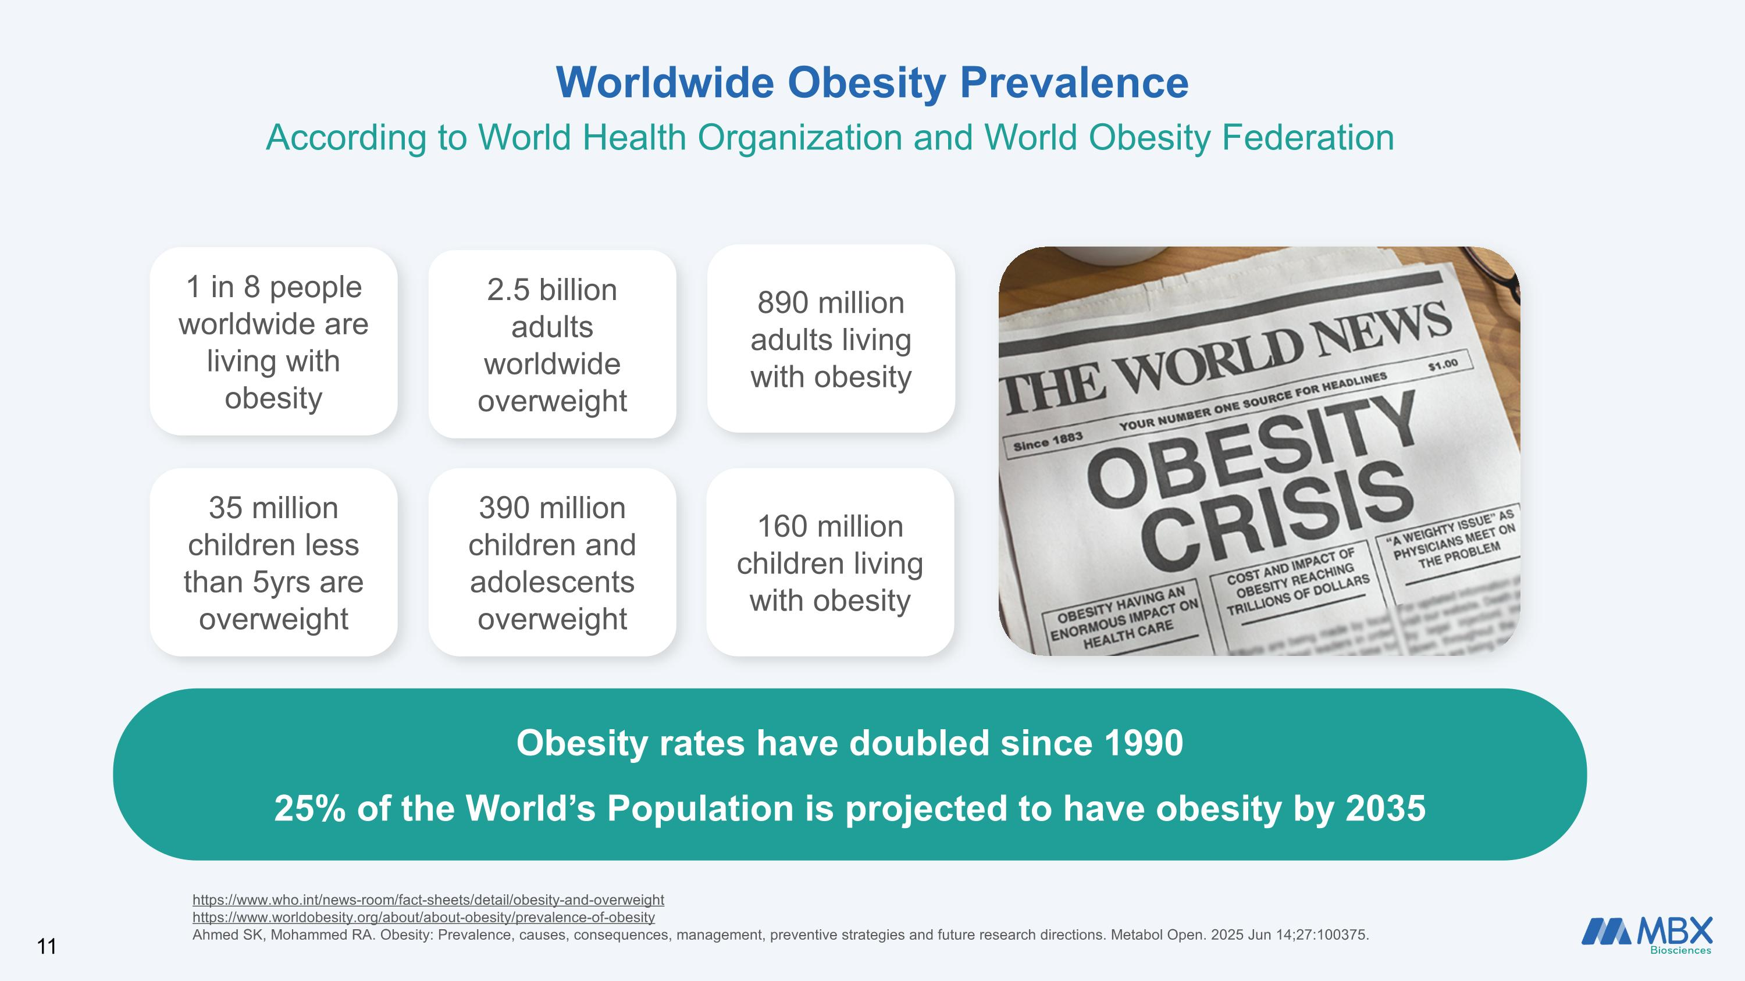
Worldwide Obesity Prevalence Obesity rates have doubled since 1990 25% of the World’s Population is projected to have obesity by 2035 390 million children and adolescents overweight 1 in 8 people worldwide are living with obesity 160 million children living with obesity 890 million adults living with obesity 2.5 billion adults worldwide overweight According to World Health Organization and World Obesity Federation https://www.who.int/news-room/fact-sheets/detail/obesity-and-overweight https://www.worldobesity.org/about/about-obesity/prevalence-of-obesity Ahmed SK, Mohammed RA. Obesity: Prevalence, causes, consequences, management, preventive strategies and future research directions. Metabol Open. 2025 Jun 14;27:100375. 35 million children less than 5yrs are overweight

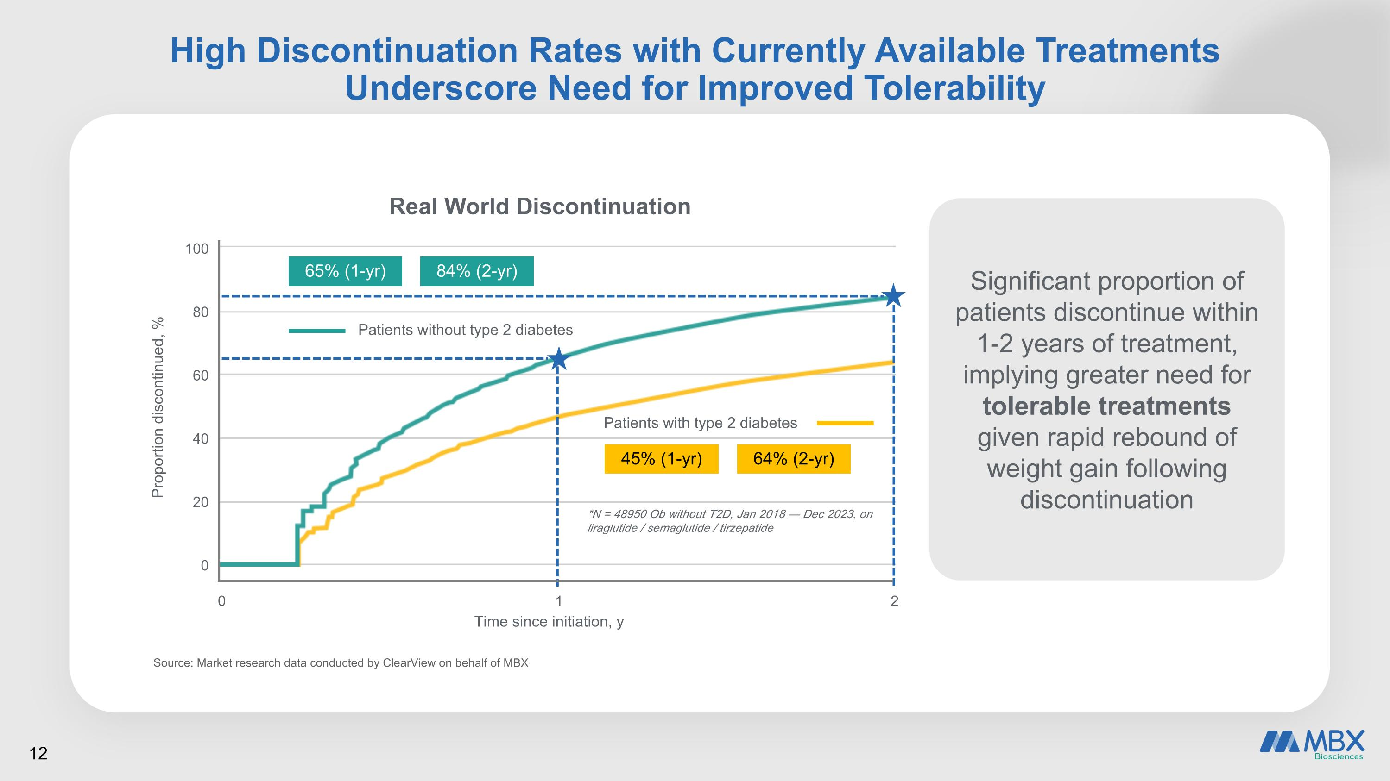
High Discontinuation Rates with Currently Available Treatments Underscore Need for Improved Tolerability Source: Market research data conducted by ClearView on behalf of MBX Proportion discontinued, % 100 80 60 40 20 0 0 1 2 Time since initiation, y Real World Discontinuation 65% (1-yr) 84% (2-yr) Patients without type 2 diabetes Patients with type 2 diabetes 45% (1-yr) 64% (2-yr) *N = 48950 Ob without T2D, Jan 2018 — Dec 2023, on liraglutide / semaglutide / tirzepatide Significant proportion of patients discontinue within 1-2 years of treatment, implying greater need for tolerable treatments given rapid rebound of weight gain following discontinuation

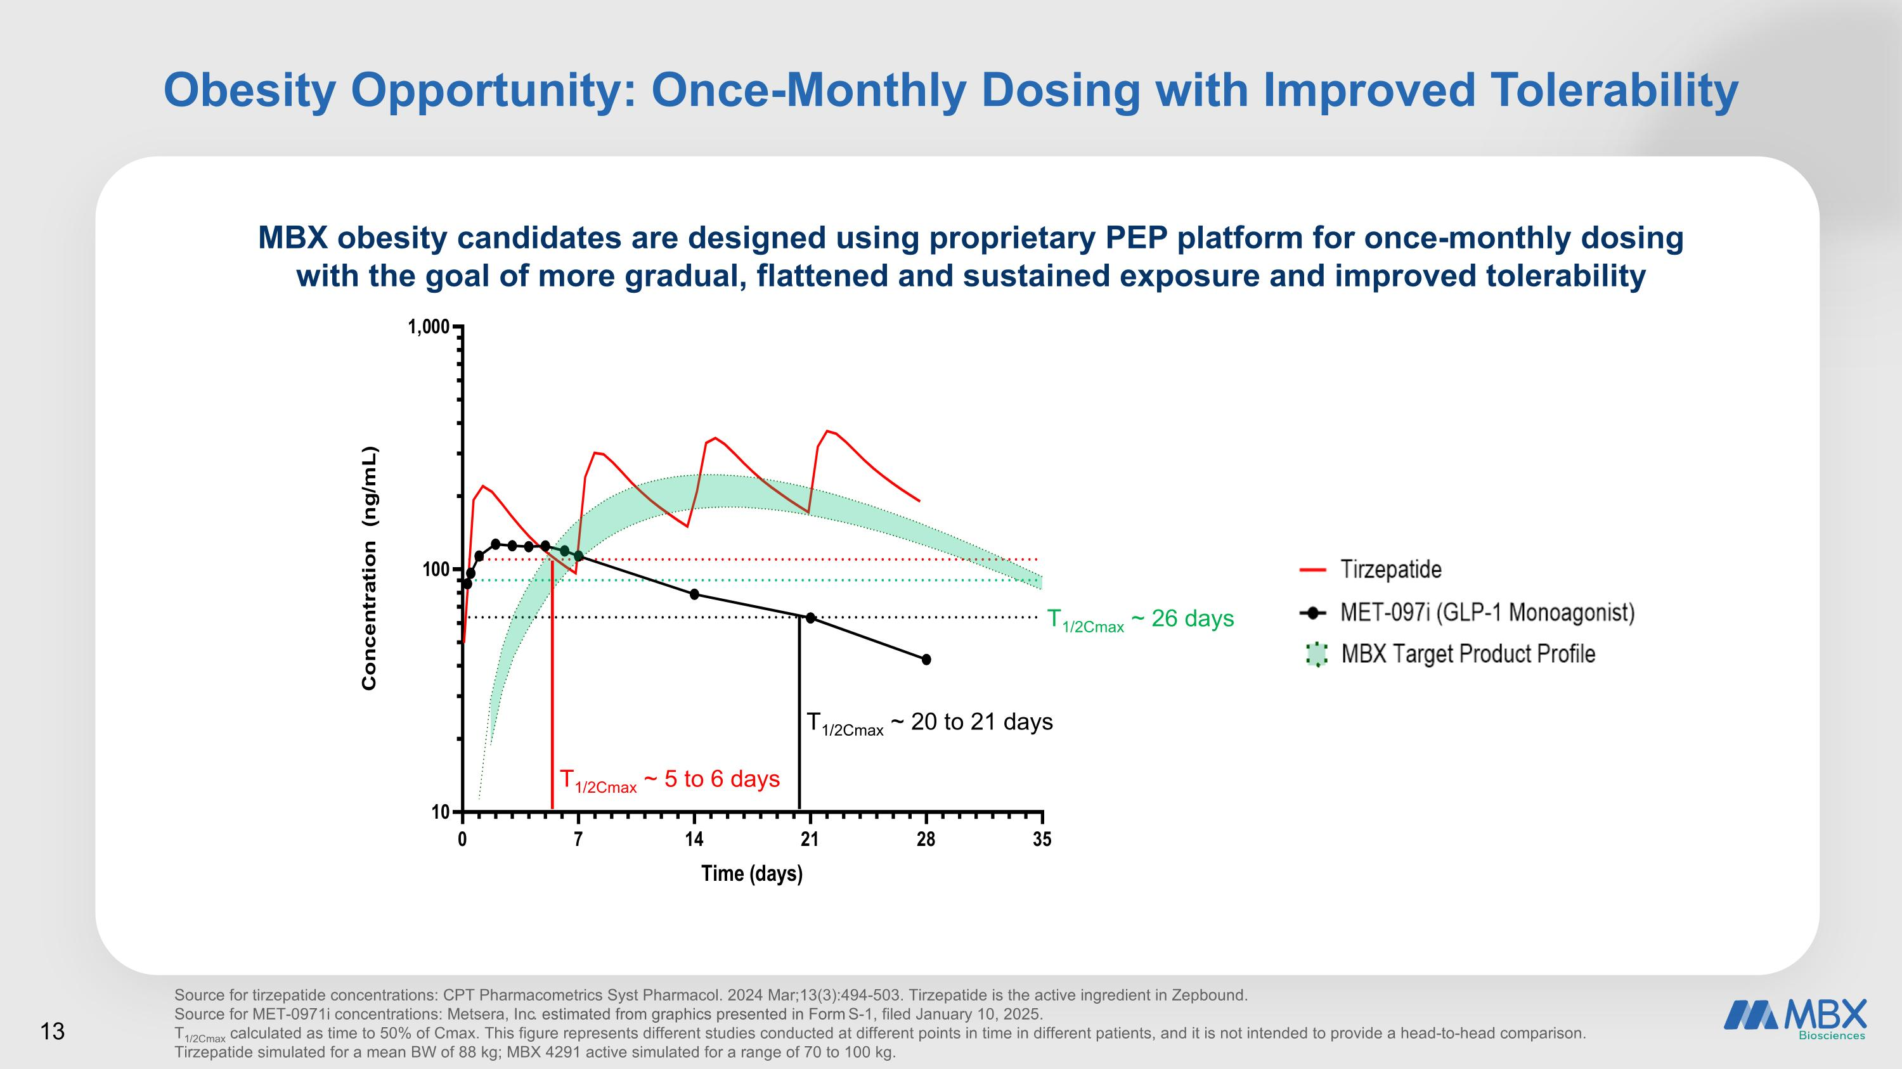
Obesity Opportunity: Once-Monthly Dosing with Improved Tolerability MBX obesity candidates are designed using proprietary PEP platform for once-monthly dosing with the goal of more gradual, flattened and sustained exposure and improved tolerability Source for tirzepatide concentrations: CPT Pharmacometrics Syst Pharmacol. 2024 Mar;13(3):494-503. Tirzepatide is the active ingredient in Zepbound. Source for MET-0971i concentrations: Metsera, Inc. estimated from graphics presented in Form S-1, filed January 10, 2025. T1/2Cmax calculated as time to 50% of Cmax. This figure represents different studies conducted at different points in time in different patients, and it is not intended to provide a head-to-head comparison.?Tirzepatide simulated for a mean BW of 88 kg; MBX 4291 active simulated for a range of 70 to 100 kg. T1/2Cmax ~ 5 to 6 days T1/2Cmax ~ 20 to 21 days T1/2Cmax ~ 26 days

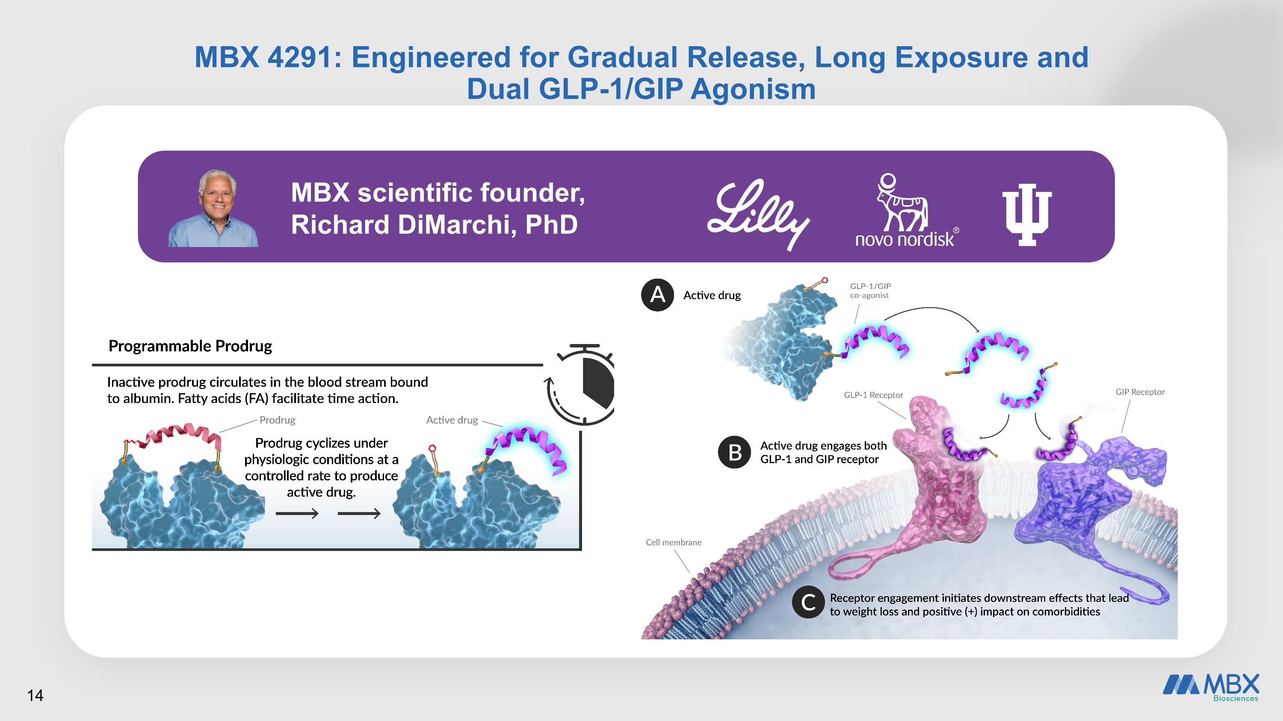
MBX 4291: Engineered for Gradual Release, Long Exposure and ?Dual GLP-1/GIP Agonism MBX scientific founder, Richard DiMarchi, PhD 14

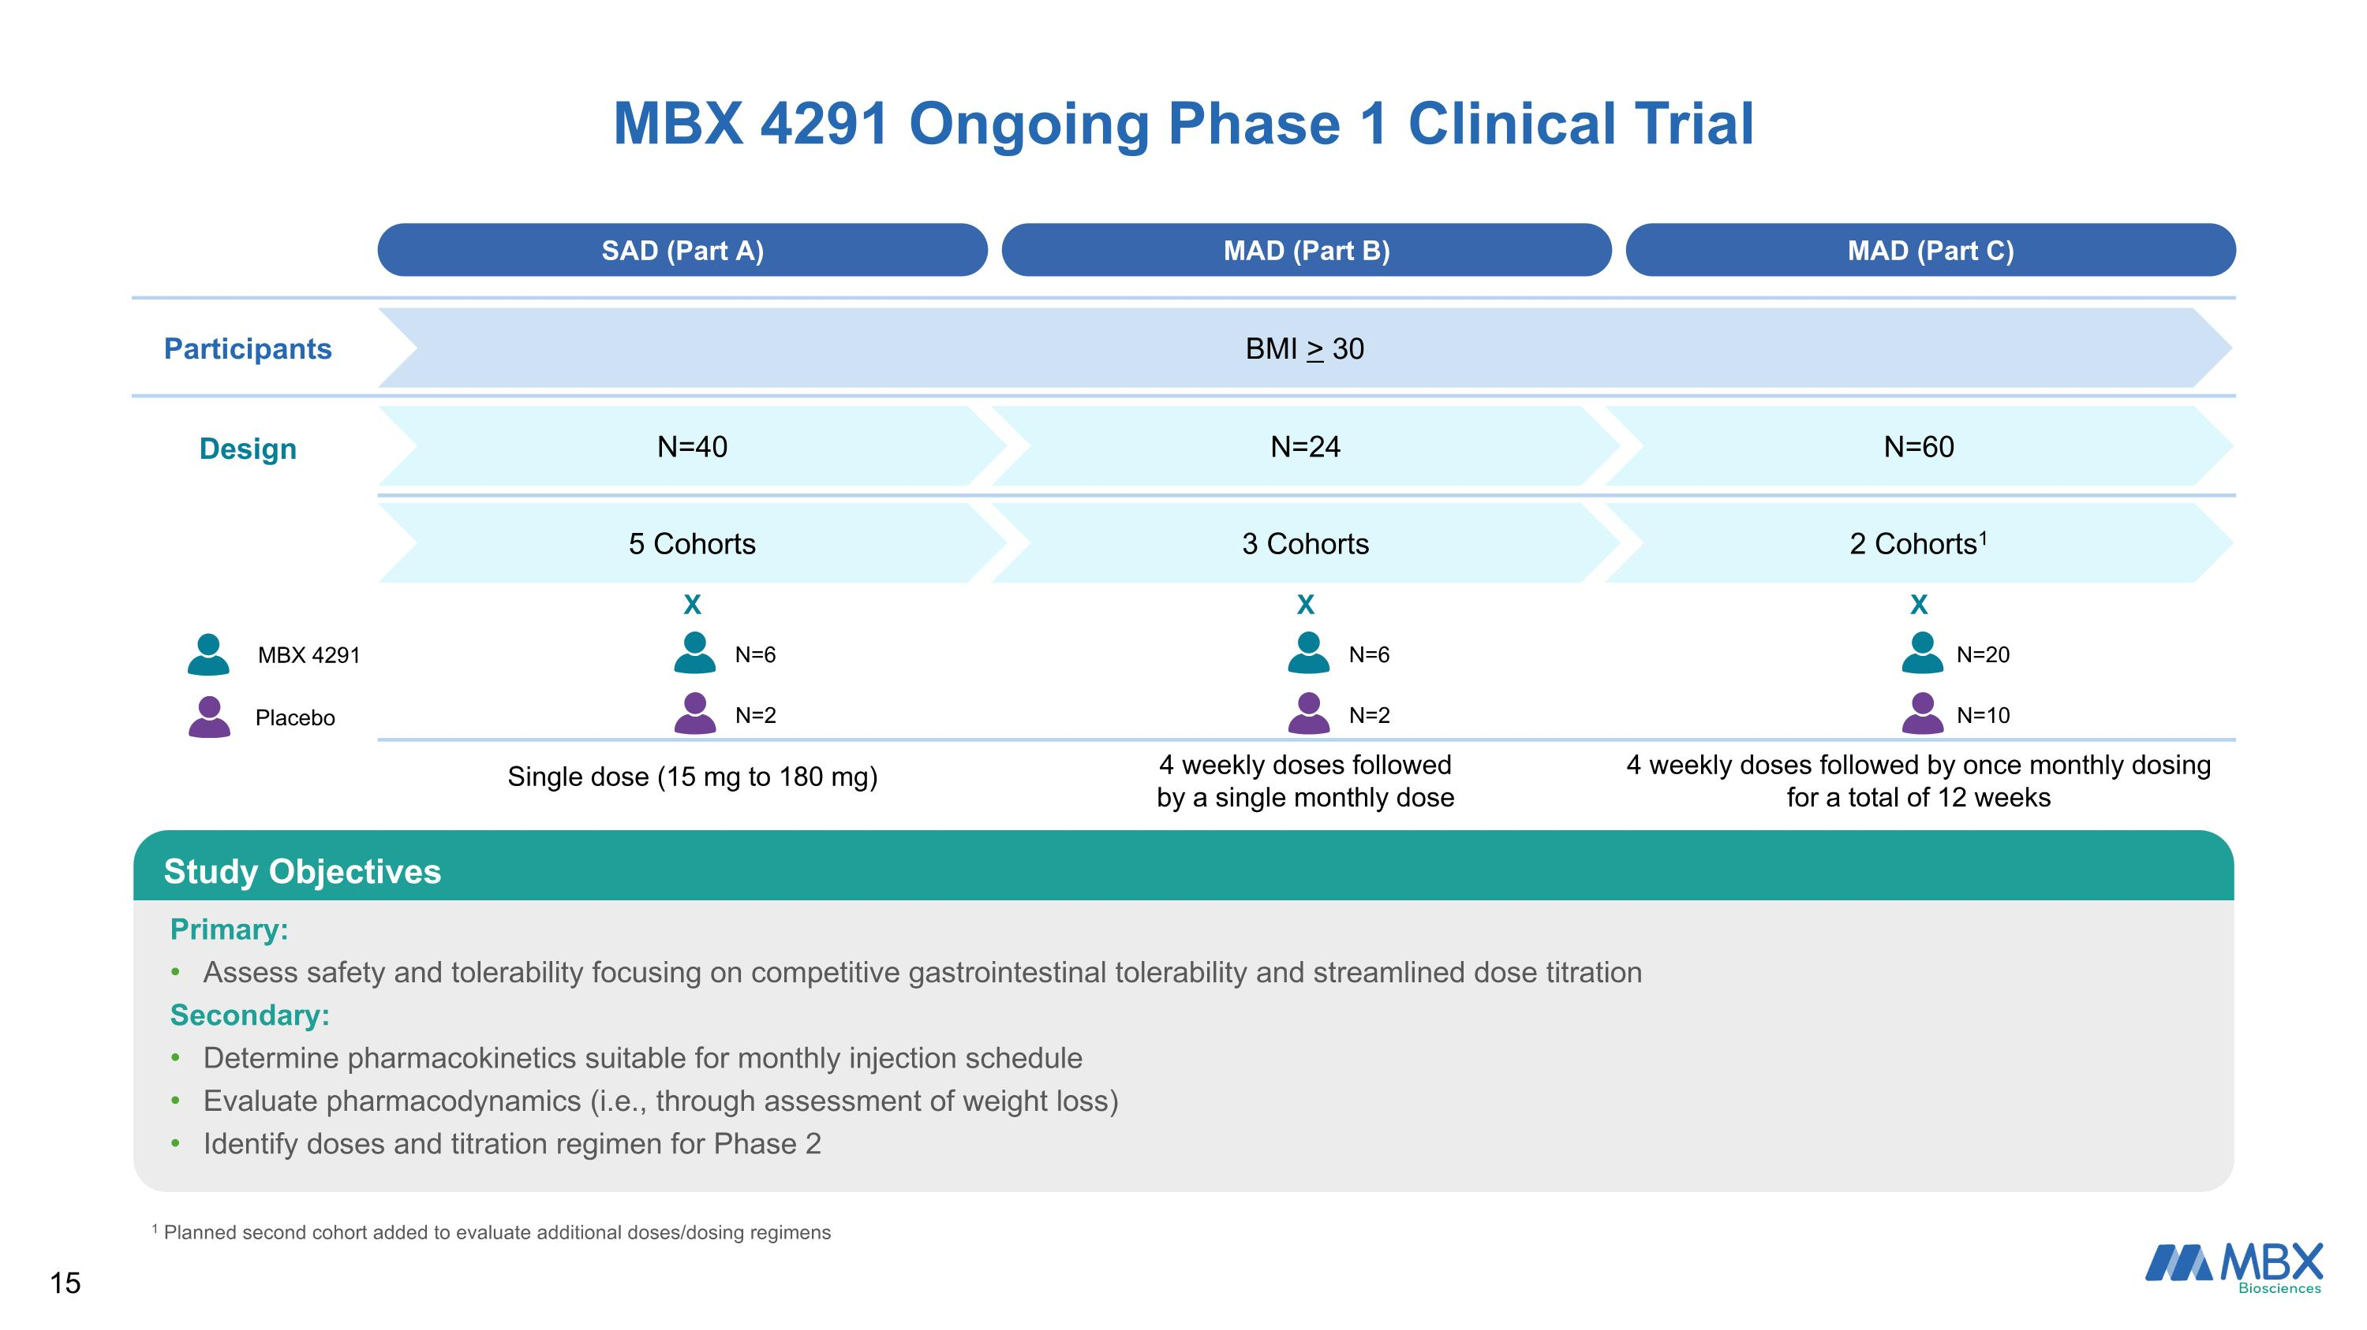
SAD (Part A) MAD (Part B) MAD (Part C) Participants BMI > 30 Design N=40 N=24 N=60 5 Cohorts 3 Cohorts 2 Cohorts1 X X X Single dose (15 mg to 180 mg) 4 weekly doses followed by a single monthly dose 4 weekly doses followed by once monthly dosing for a total of 12 weeks MBX 4291 Ongoing Phase 1 Clinical Trial Primary: Assess safety and tolerability focusing on competitive gastrointestinal tolerability and streamlined dose titration Secondary: Determine pharmacokinetics suitable for monthly injection schedule Evaluate pharmacodynamics (i.e., through assessment of weight loss) Identify doses and titration regimen for Phase 2 Study Objectives MBX 4291 Placebo N=6 N=2 N=6 N=2 N=20 N=10 1 Planned second cohort added to evaluate additional doses/dosing regimens

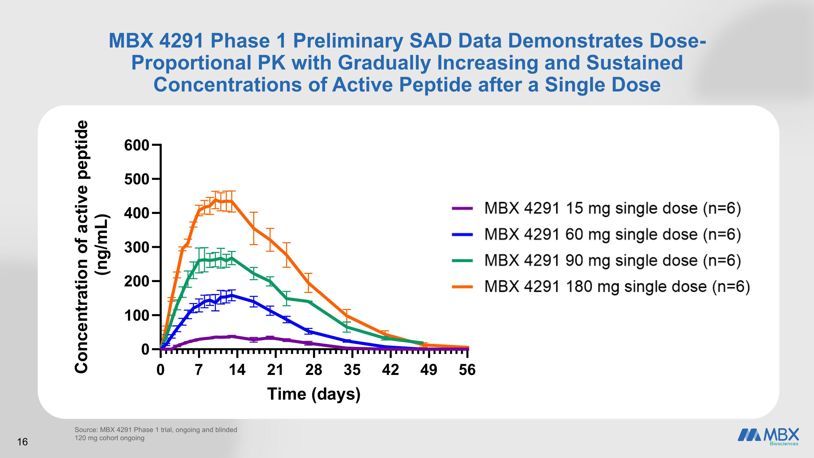
MBX 4291 Phase 1 Preliminary SAD Data Demonstrates Dose-Proportional PK with Gradually Increasing and Sustained Concentrations of Active Peptide after a Single Dose Source: MBX 4291 Phase 1 trial, ongoing and blinded 120 mg cohort ongoing

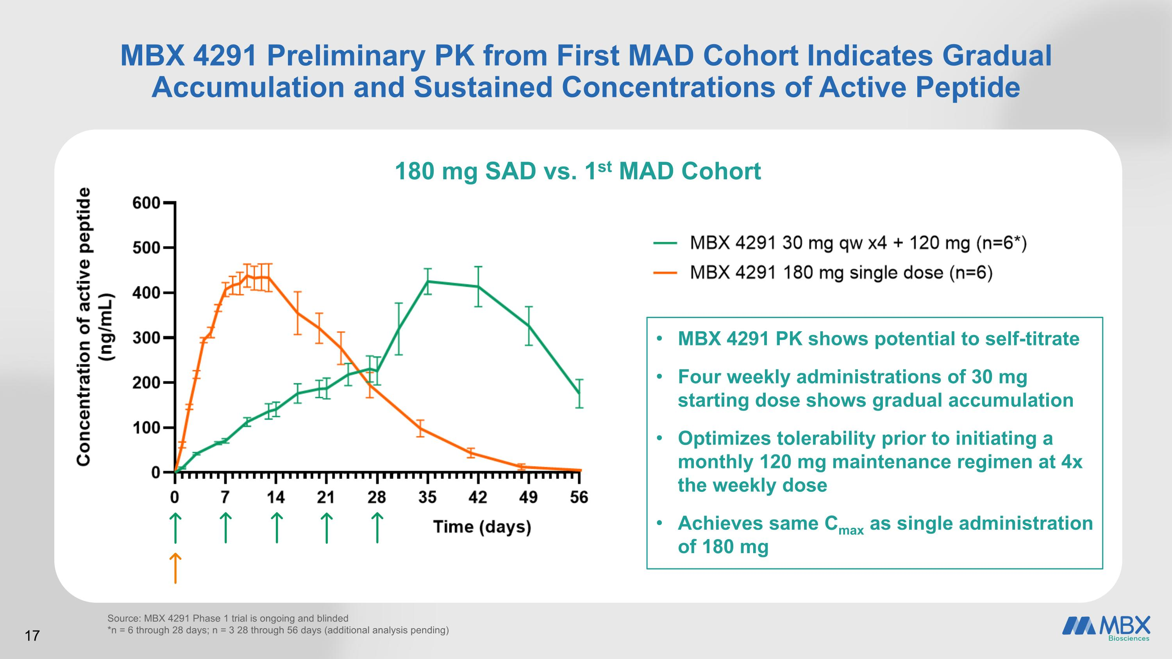
MBX 4291 Preliminary PK from First MAD Cohort Indicates Gradual Accumulation and Sustained Concentrations of Active Peptide Source: MBX 4291 Phase 1 trial is ongoing and blinded *n = 6 through 28 days; n = 3 28 through 56 days (additional analysis pending) 180 mg SAD vs. 1st MAD Cohort 17 MBX 4291 PK shows potential to self-titrate Four weekly administrations of 30 mg starting dose shows gradual accumulation Optimizes tolerability prior to initiating a monthly 120 mg maintenance regimen at 4x the weekly dose Achieves same Cmax as single administration of 180 mg

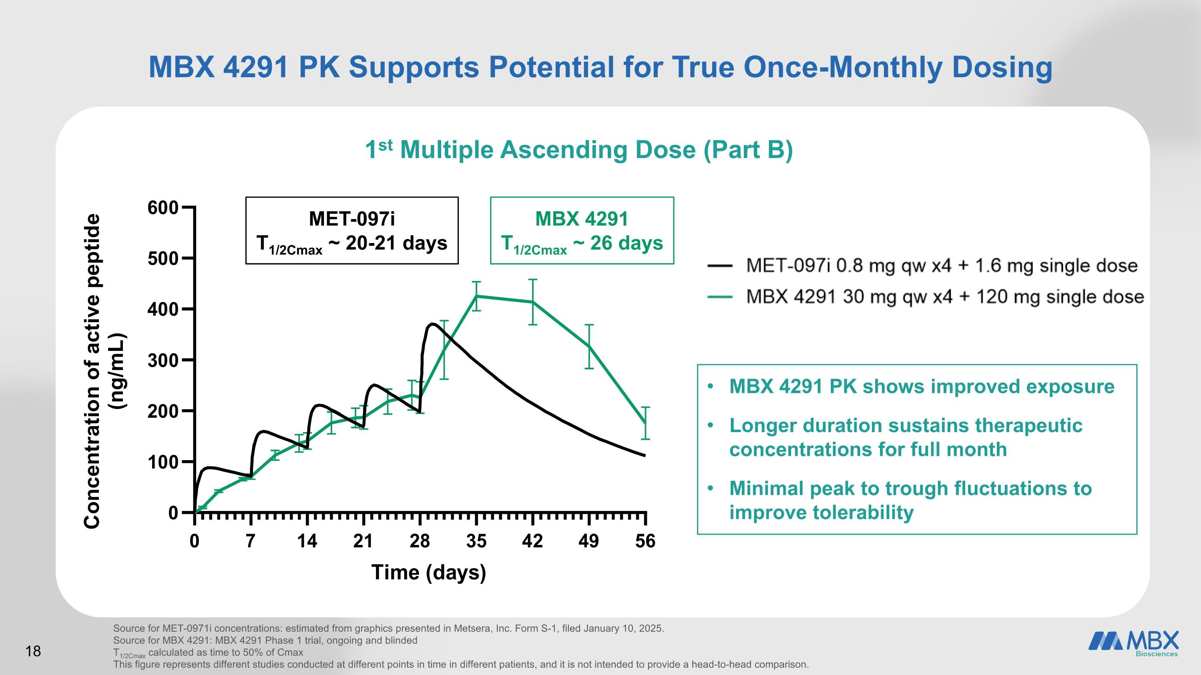
MBX 4291 PK Supports Potential for True Once-Monthly Dosing 1st Multiple Ascending Dose (Part B) Source for MET-0971i concentrations: estimated from graphics presented in Metsera, Inc. Form S-1, filed January 10, 2025. Source for MBX 4291: MBX 4291 Phase 1 trial, ongoing and blinded T1/2Cmax calculated as time to 50% of Cmax This figure represents different studies conducted at different points in time in different patients, and it is not intended to provide a head-to-head comparison. MET-097i T1/2Cmax ~ 20-21 days MBX 4291 T1/2Cmax ~ 26 days MBX 4291 PK shows improved exposure Longer duration sustains therapeutic concentrations for full month Minimal peak to trough fluctuations to improve tolerability 18

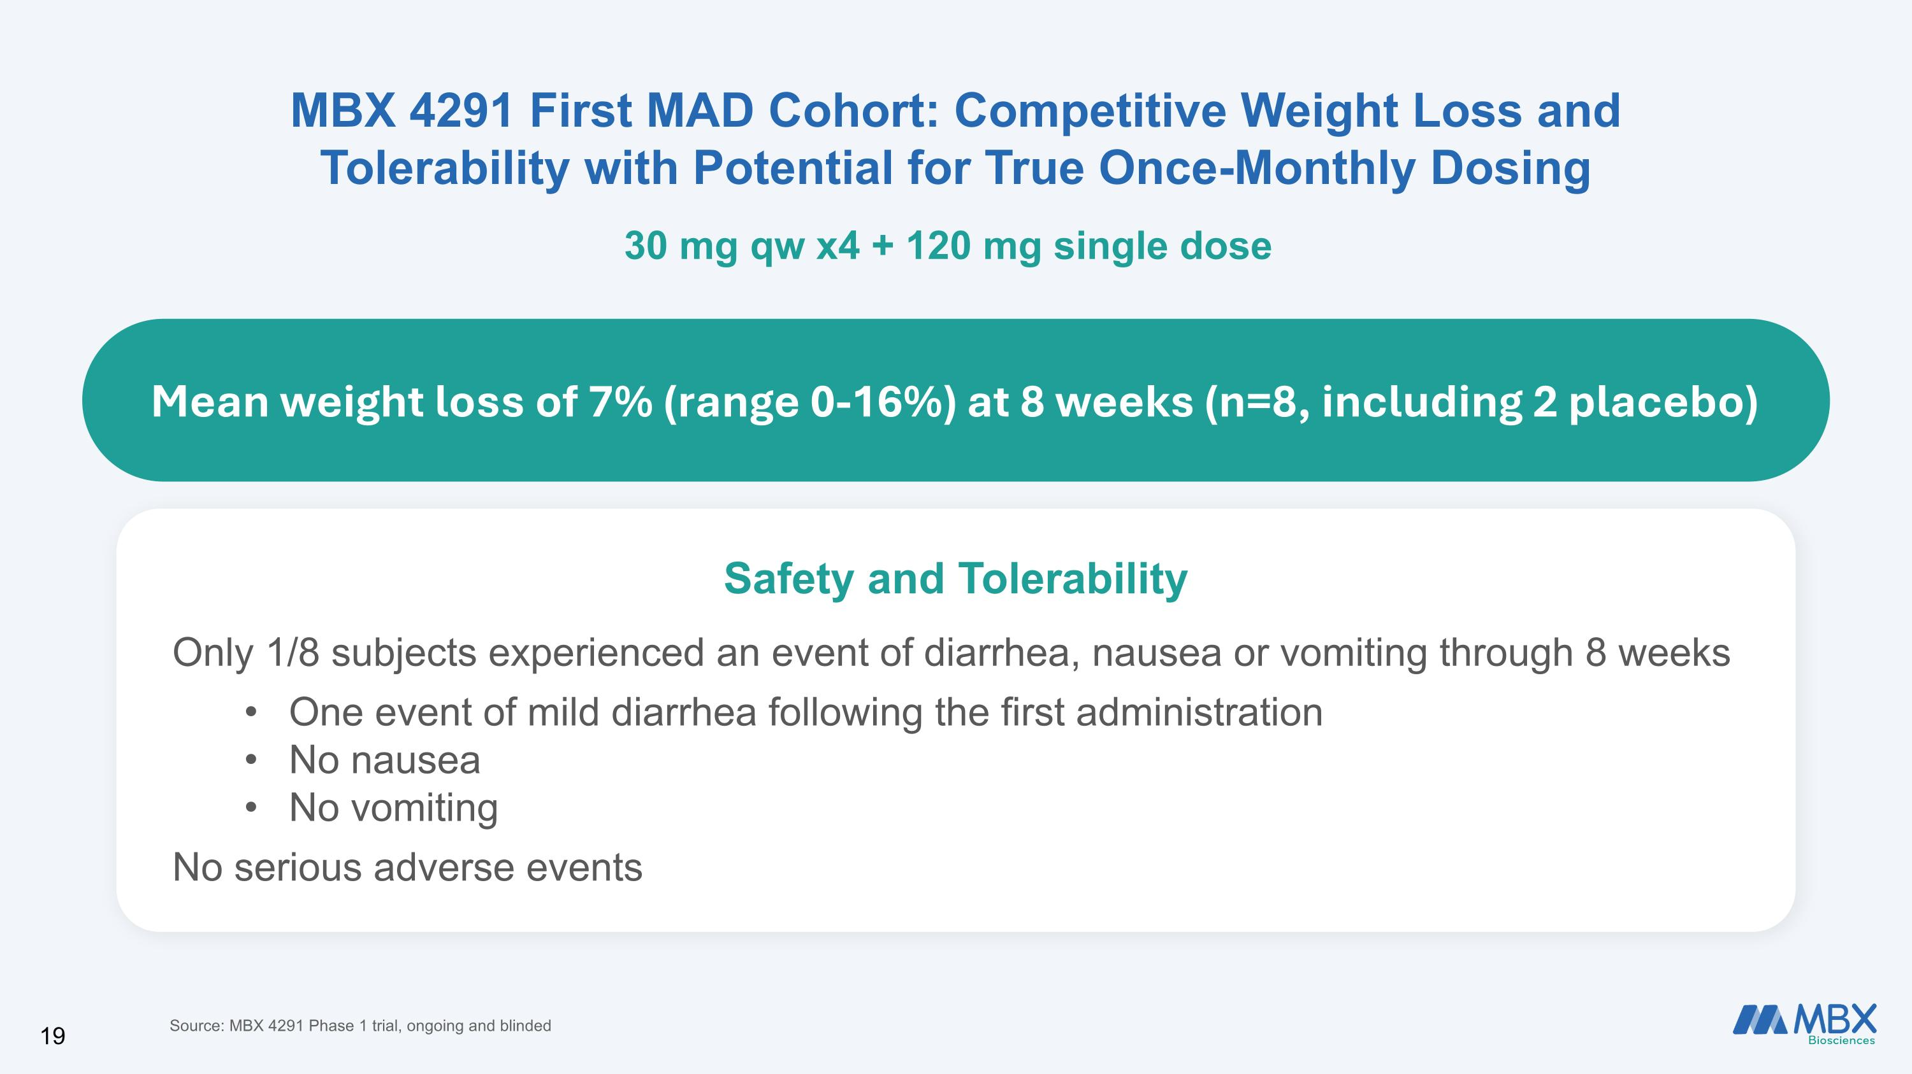
Mean weight loss of 7% (range 0-16%) at 8 weeks (n=8, including 2 placebo) MBX 4291 First MAD Cohort: Competitive Weight Loss and?Tolerability with Potential for True Once-Monthly Dosing 30 mg qw x4 + 120 mg single dose Safety and Tolerability Only 1/8 subjects experienced an event of diarrhea, nausea or vomiting through 8 weeks One event of mild diarrhea following the first administration No nausea No vomiting No serious adverse events Source: MBX 4291 Phase 1 trial, ongoing and blinded

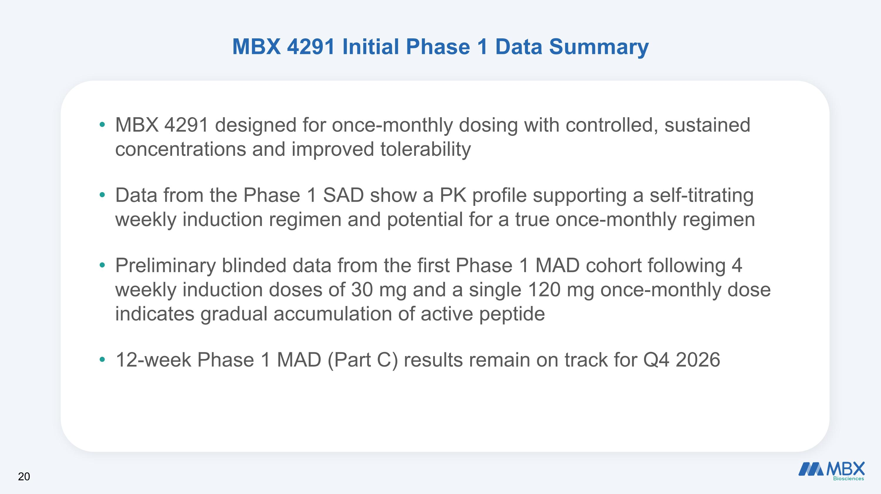
MBX 4291 Initial Phase 1 Data Summary MBX 4291 designed for once-monthly dosing with controlled, sustained concentrations and improved tolerability Data from the Phase 1 SAD show a PK profile supporting a self-titrating weekly induction regimen and potential for a true once-monthly regimen Preliminary blinded data from the first Phase 1 MAD cohort following 4 weekly induction doses of 30 mg and a single 120 mg once-monthly dose indicates gradual accumulation of active peptide 12-week Phase 1 MAD (Part C) results remain on track for Q4 2026

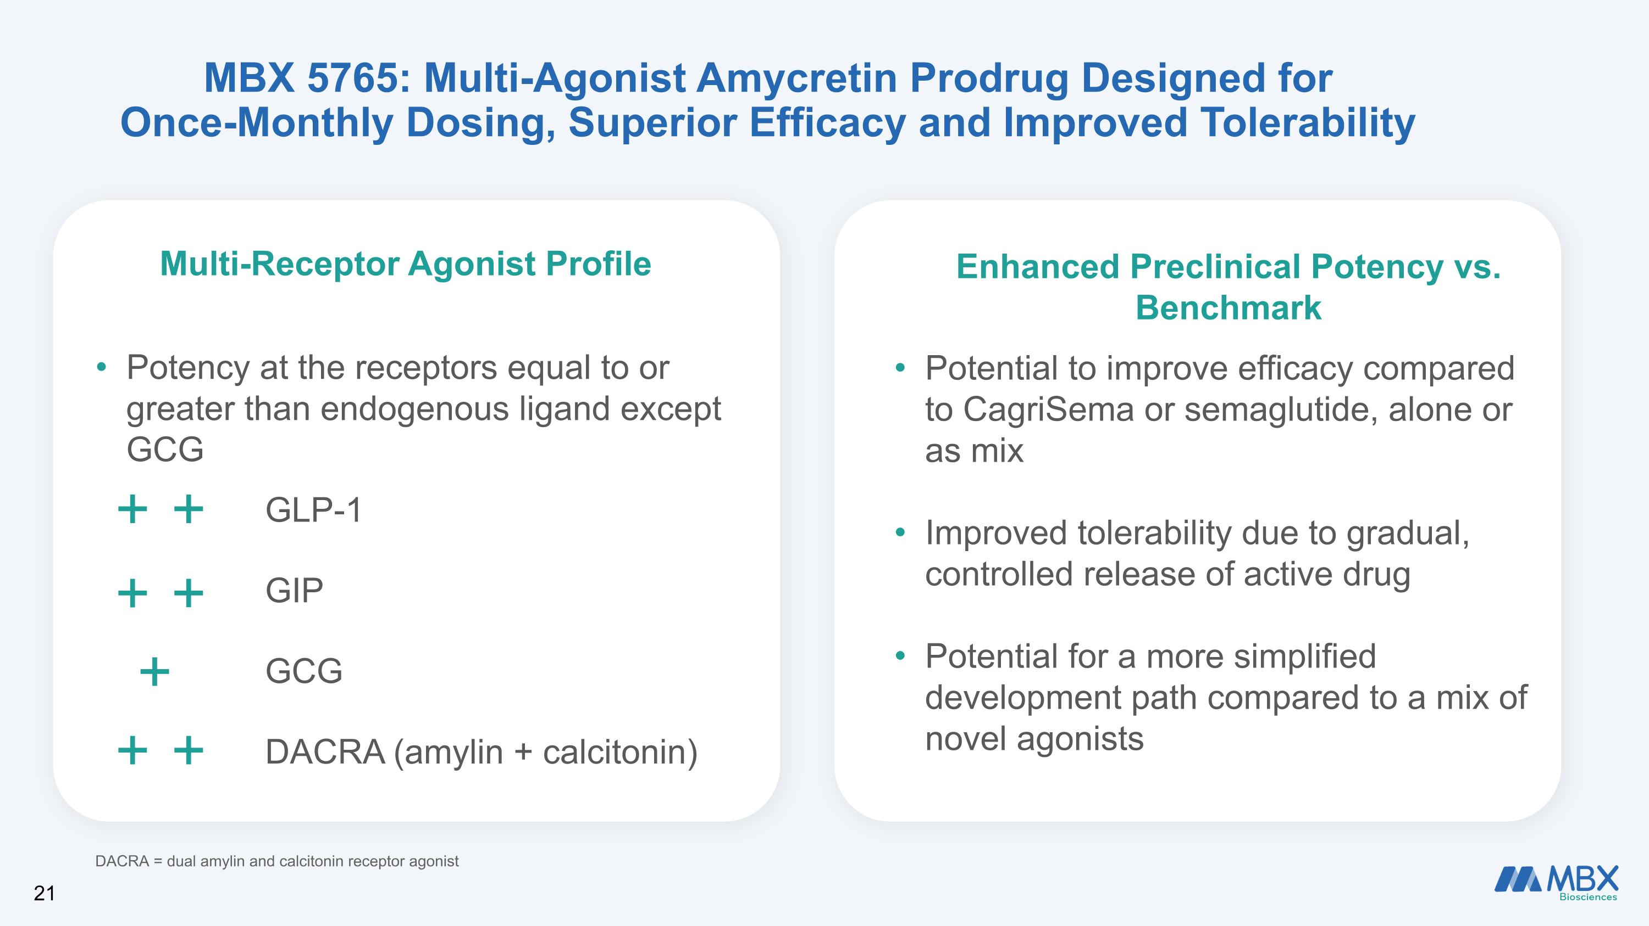
GLP-1 GIP GCG DACRA (amylin + calcitonin) Potential to improve efficacy compared to CagriSema or semaglutide, alone or as mix Improved tolerability due to gradual, controlled release of active drug Potential for a more simplified development path compared to a mix of novel agonists MBX 5765: Multi-Agonist Amycretin Prodrug Designed for ?Once-Monthly Dosing, Superior Efficacy and Improved Tolerability Potency at the receptors equal to or greater than endogenous ligand except GCG DACRA = dual amylin and calcitonin receptor agonist Multi-Receptor Agonist Profile Enhanced Preclinical Potency vs. Benchmark 21

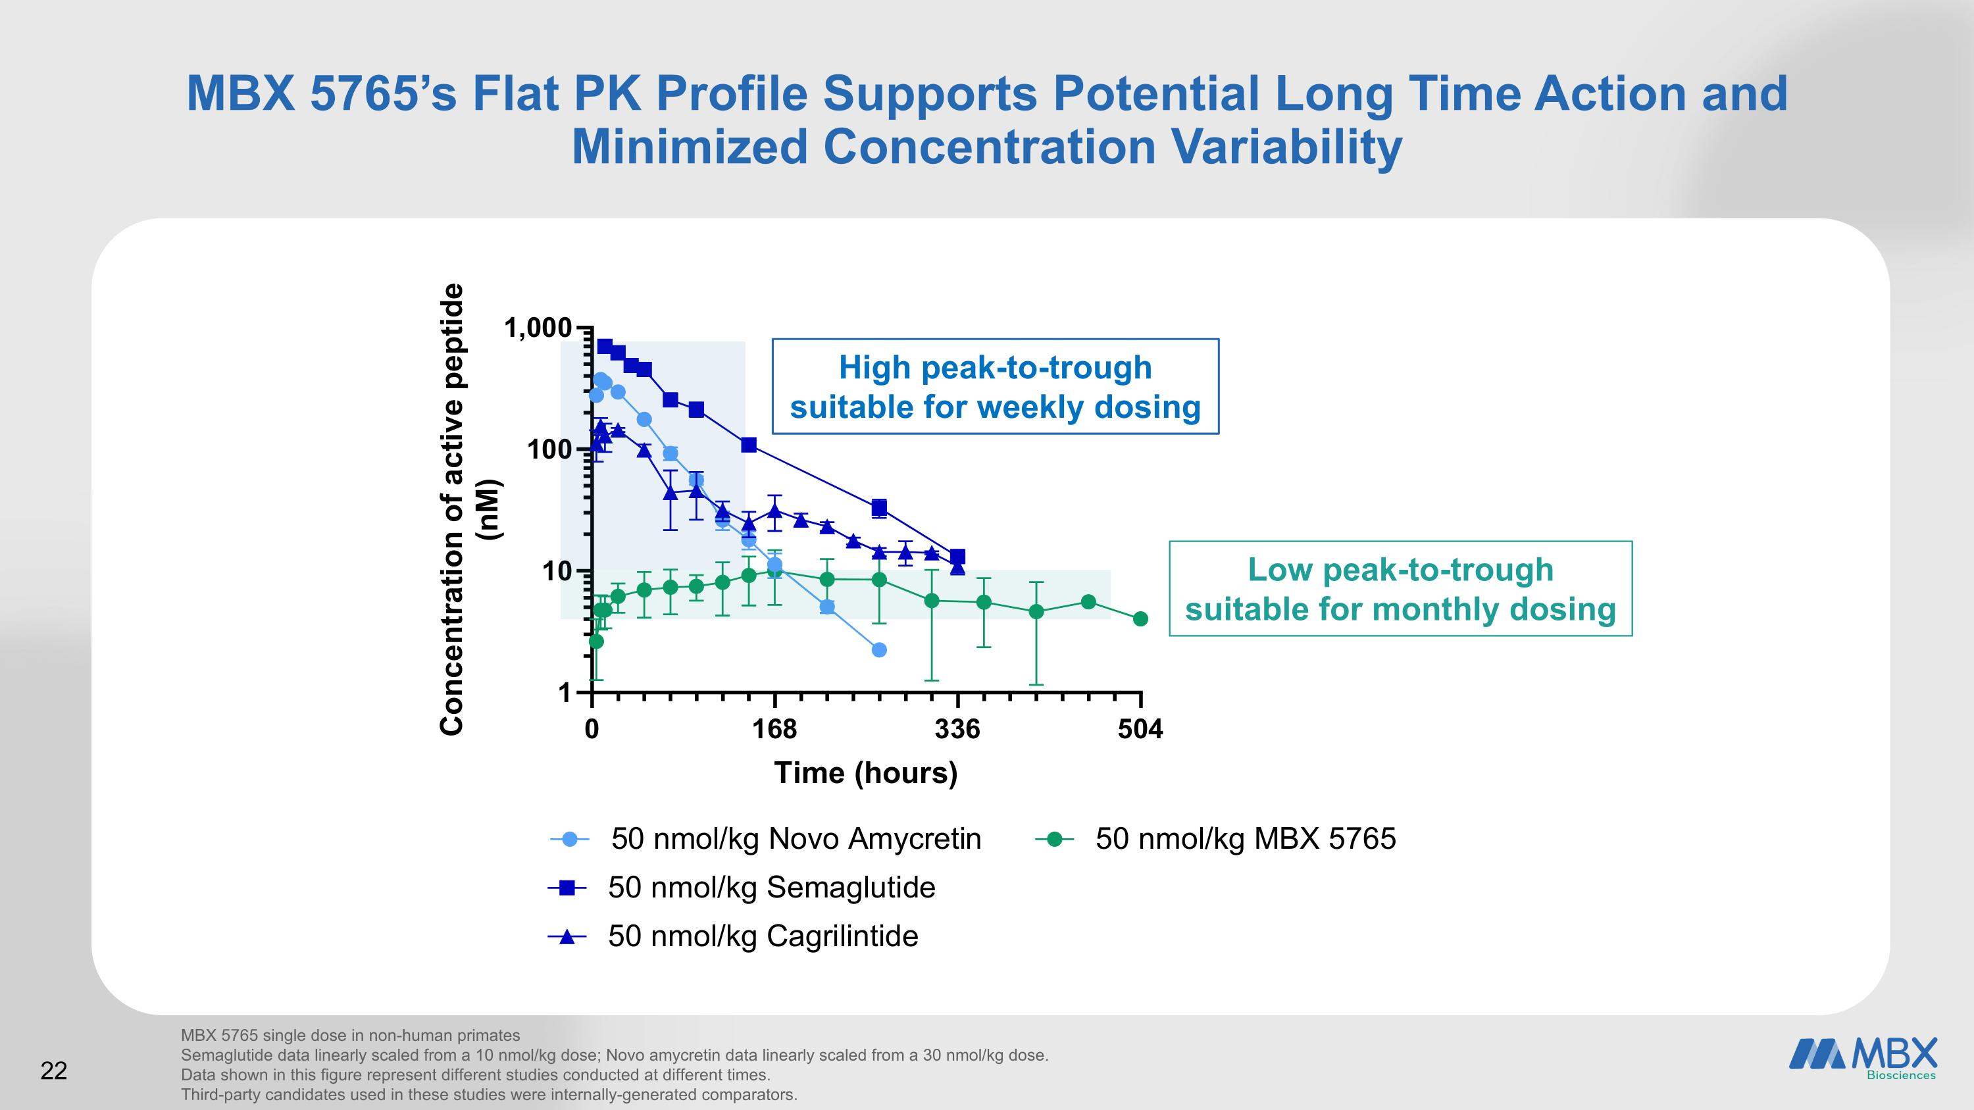
22 we MBX 5765’s Flat PK Profile Supports Potential Long Time Action and ?Minimized Concentration Variability MBX 5765 single dose in non-human primates Semaglutide data linearly scaled from a 10 nmol/kg dose; Novo amycretin data linearly scaled from a 30 nmol/kg dose. Data shown in this figure represent different studies conducted at different times. Third-party candidates used in these studies were internally-generated comparators. High peak-to-trough suitable for weekly dosing Low peak-to-trough suitable for monthly dosing

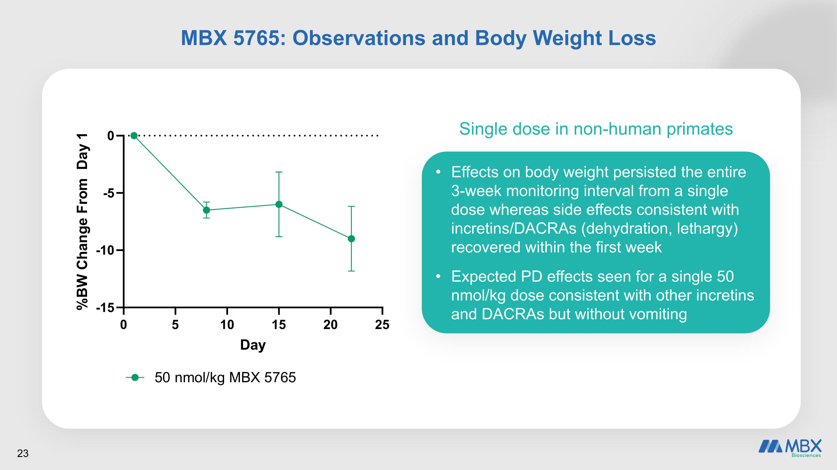
MBX 5765: Observations and Body Weight Loss Effects on body weight persisted the entire 3-week monitoring interval from a single dose whereas side effects consistent with incretins/DACRAs (dehydration, lethargy) recovered within the first week Expected PD effects seen for a single 50 nmol/kg dose consistent with other incretins and DACRAs but without vomiting 23 Single dose in non-human primates

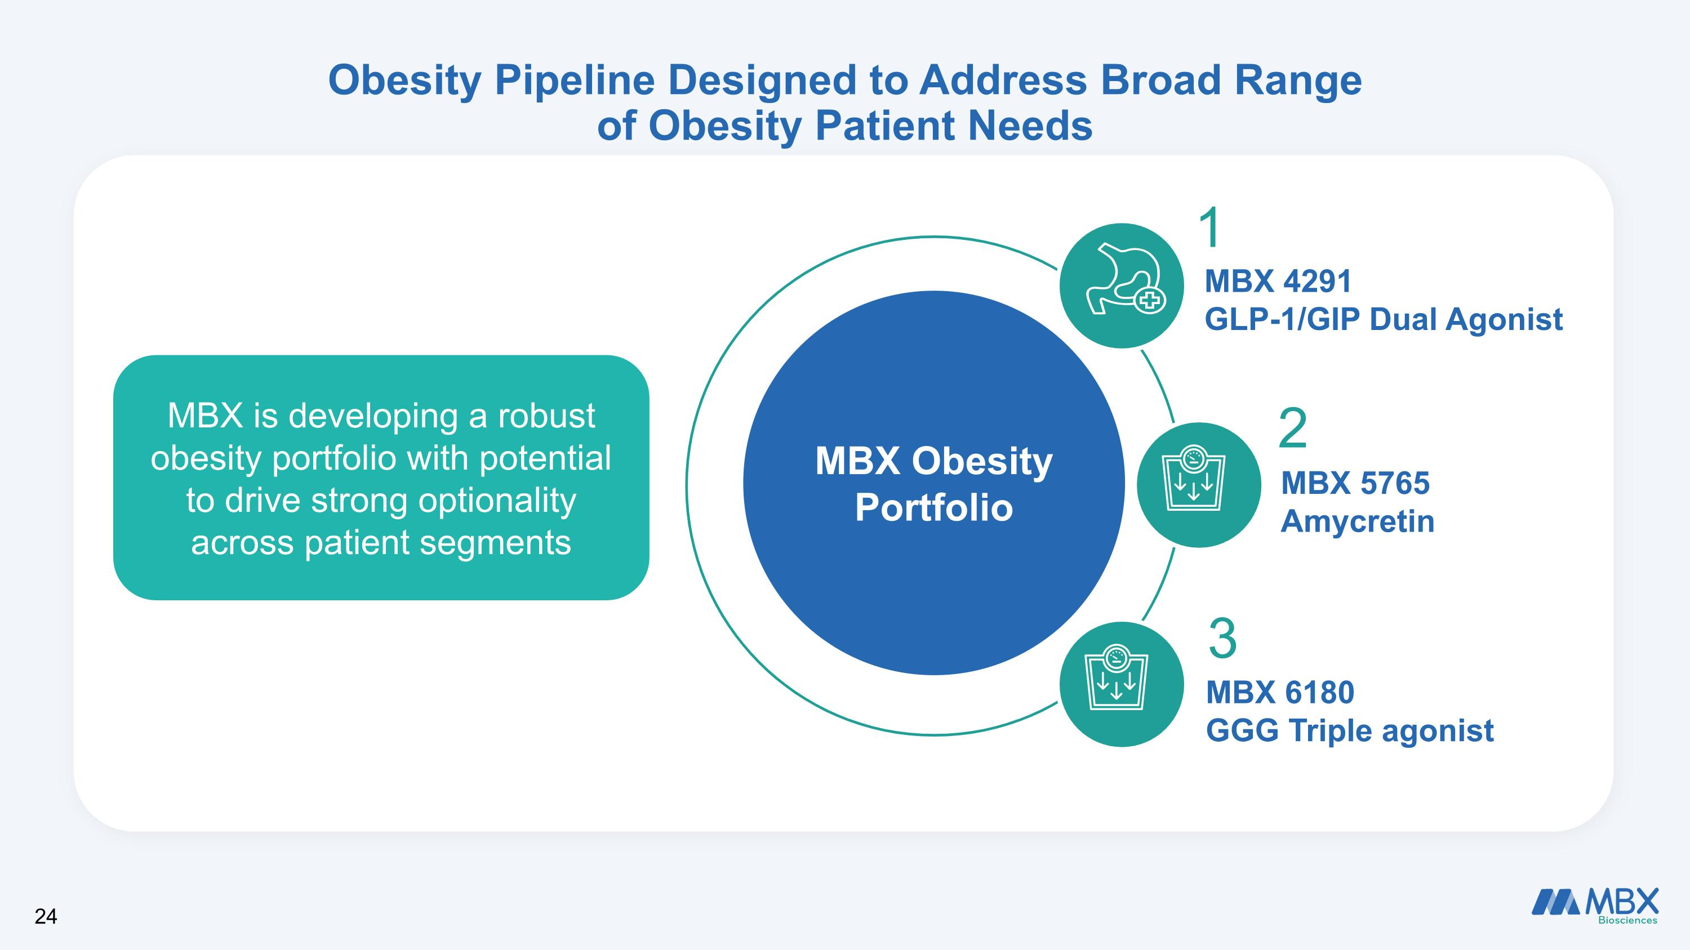
Obesity Pipeline Designed to Address Broad Range ?of Obesity Patient Needs MBX Obesity Portfolio MBX 4291 GLP-1/GIP Dual Agonist MBX 5765 Amycretin MBX 6180 GGG Triple agonist 1 2 3 MBX is developing a robust obesity portfolio with potential to drive strong optionality across patient segments 24

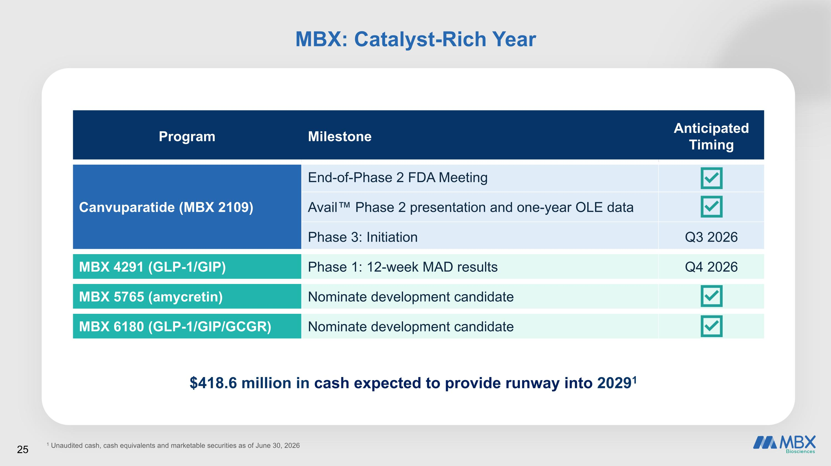
$418.6 million in cash expected to provide runway into 20291 Program Milestone Anticipated Timing Canvuparatide (MBX 2109) End-of-Phase 2 FDA Meeting Avail Phase 2 presentation and one-year OLE data Phase 3: Initiation Q3 2026 MBX 4291 (GLP-1/GIP) Phase 1: 12-week MAD results Q4 2026 MBX 5765 (amycretin) Nominate development candidate MBX 6180 (GLP-1/GIP/GCGR) Nominate development candidate 1 Unaudited cash, cash equivalents and marketable securities as of June 30, 2026 MBX: Catalyst-Rich Year 25


Transforming the Lives of People Impacted by Endocrine and Metabolic Diseases through Precision Peptides Our Mission

